Supplementary materials
Appendix I

Characterization of the synthetic standards.
High-resolution MS (HRMS) measurements of the synthetic standards were acquired by direct injection (Orbitrap XL, Thermo-Fisher, San Jose, CA, USA). Infrared spectra were measured with an IR spectrometer over a range of 700−4000 cm⁻¹ in transmission mode with a spectral resolution of 2 cm⁻¹. Optical rotations were measured at 589 nm in water (temperatures are given). NMR spectra were measured using a Bruker AV400 spectrometer operating at 400 MHz (¹H) and 100 MHz (¹³C). Chemical shifts (δ) are quoted in parts per million (ppm) and are referenced to the signal of residual protonated solvent (CD₃OD at 3.31 ppm in ¹H and 49.0 ppm in ¹³C). MeOH was added as a reference for ¹³C NMR spectra in D₂O (δ 49.5 ppm). Assignment of peaks was carried out using 1D (¹H, ¹³C {¹H}, APT, DEPT) and 2D NMR experiments (COSY and HSQC). The multiplicities are given as follows: d, doublet; t, triplet; dd, doublet of doublets; q, quartet; m, multiplet.

Synthesis of stable isotope labelled 3-[1-¹³C,3-¹⁵N]-3-NPA (98% ¹³C, 95% ¹⁵N)

The synthesis of 3-[1-¹³C, 3-¹⁵N]-nitropropanoic acid was achieved using the protocol of Baxter et al (1985) with Na¹⁵NO₂ to introduce a second stable isotope label. The analytical data were in excellent agreement with the literature results.

Synthesis of amino acid amides of 3-NPA
Due to the low solubility of free amino acids in non-aqueous solvents the synthesis of the described 3-NPA amino acid amides 1-4 was performed counterintuitively in an aqueous solution at rt using dicyclohexyl carbodiimide (DCC) as a coupling reagent (Scheme 1) (Neises, and Steglich, 1978; Becker et al, 2015). 3-NPA was dissolved in small amounts of water. To the aqueous solution DCC in acetonitrile and the free amino acid in water were added over 2h simultaneously. The mixtures were purified by extraction and column chromatography (Et₂O/AcOH). This procedure provides significant amounts of the natural products in one synthetic step without the need of protecting groups.
Scheme 1: Synthetic protocol for the amino acid amides of 3-NPA; a) DCC/MeCN 0.4 M, amino acid/H₂O 0.4 M, rt, 2h, H₂O.
General synthesis of the 3-Nitropropanoic acid (3-NPA) amides of amino acids 1 to 4.
To a solution of 750 mg (6.3 mmol, 1.05 equ.) 3-NPA in water (0.4 ml) a solution of 1.3 g (6.3 mmol, 1.05 equ.) DCC in 20 ml MeCN and 1 equ. of the amino acid in 20 ml water were added drop wise and simultaneously over 2 h at rt. After the addition was completed 400 ml of MeCN were added so that the solvents were removed completely at 75 mbar and 25°C. To the dry crude mixture 15 ml of water were added to extract the amino acid derivatives from the water insoluble DCU and the suspension was shaken for 30 min at rt. After the mixture was filtrated and washed with 10 ml of water 300 ml MeCN and 3g dry Silica were added to the filtrate. The solvents were removed under reduced pressure and rt. The silica adsorbed crude mixture was applied to a column and eluted with ethyl ether/acetic acid (ratios are given as follows). The product fractions were combined, the same volume of cyclohexane was added and the solvents were removed under reduced pressure at rt. To the oily residue 3 ml of cyclohexane and 3 ml of diethyl ether were added and the solvents were removed again at rt under reduced pressure. This procedure was repeated until a colorless solid was obtained.
The columns for preparative chromatography were packed by pouring a suspension of silica gel (0.03-0.063 mm) and the eluent into the column containing 10 ml of the eluent. The separations were carried out at 1.1 bar additional pressure.
Thin-layer chromatography was performed on TLC silica gel 60 F254 aluminum sheets. Compounds were visualized using anisaldehyde reagent. All chemicals were purchased in the highest purity that was commercially available and used without further purification. All solvents were purchased in HPLC grade and used without further purification. Diethyl ether was distilled prior to use.

Analytical data for (3-nitropropanoyl)glycine 1: (135 mg, 0.77 mmol, 12.8 %); R_{f}(Et₂O/AcOH 7:1)=0.21; ¹H NMR (400 MHz, CD₃OD): 4.71 (t, J = 6.1 Hz, 2H, H-3´), 3.92 (s, 2H, H-2), 2.95 (t, J = 6.1 Hz, 2H; H-2´); ¹³C NMR (100 MHz, CD₃OD): 173.0 (C-1 or C-1´), 172.0 (C-1 or C-1´), 71.1 (C-3´), 41.9 (C-2), 32.9 (C-2´); MS (ESI-TOF, neg. mode) m/z (in %) 373.06 (100) [M₂-2H+Na]⁻, 175.04 (27) [M-H]⁻, 128.04 (88) [M-H-HNO₂]⁻; HRMS (ESI-TOF, neg. mode) m/z calcd for C₅H₇N₂O₅⁻ 175.03604 [M-H]⁻, found 175.03546; IR (thin film, cm⁻¹) 3314 (br, s), 3078 (m), 2980 (m), 2927 (m), 1702 (s), 1652 (s), 1555 (s), 1427 (s), 1408 (s), 1377 (s), 1235 (s), 1208 (m). These data are in excellent agreement with the literature results (Majak, W., et al 1998).

Analytical data for (3-nitropropanoyl)alanine 2: (93 mg, 0.49 mmol, 8.2 %); [α]_{D}²¹ -17.6 (c 0.75, CD₃OD); R_{f}(Et₂O/AcOH 14:1)=0.24; ¹H NMR (400 MHz, CD₃OD): 4.70 (m, 2H, H-3´), 4.39 (q, J = 7.3 Hz, 1H, H-2), 2.92 (m, 2H; H-2´), 1.40 (d, J = 7.3 Hz, 3H, H-3); ¹³C NMR (100 MHz, D₂O): 177.3 (C-1 or C-1´), 172.4 (C-1 or C-1´), 70.9 (C-3´), 49.5 (C-2), 32.2 (C-2´), 16.7 (C-3); MS (ESI-TOF, neg. mode) m/z (in %) 379.11 (40) [M₂-H]⁻, 189.05 (60) [M-H]⁻, 142.05 (100) [M-H-HNO₂]⁻; HRMS (ESI-TOF, neg. mode) m/z calcd for C₆H₉N₂O₅⁻ 189.05169 [M-H]⁻, found 189.05253; IR (thin film, cm⁻¹) 3320 (br, s), 2987 (m), 2941 (m), 1731 (s), 1659 (s), 1556 (s), 1457 (m), 1419 (m), 1378 (m), 1224 (m), 1157 (m).

Analytical data for (3-nitropropanoyl)serine 3: (117 mg, 0.57 mmol, 9.4 %); [α]_{D}²² 15.2 (c 1.12, CD₃OD); R_{f}(Et₂O/AcOH 7:2)=0.21; ¹H NMR (400 MHz, CD₃OD): 4.71 (m, 2H, H-3´), 4.46 (br, t, J = 4.4 Hz, 1H, H-2), 3.89 (dd, J₁ = 11.2 Hz, J₂ = 4.9, 1H; H_{A}-3), 3.81 (dd, J₁ = 11.2 Hz, J₂ = 4.1, 1H; H_{B}-3), 2.98 (m, 2H, H-2´); ¹³C NMR (100 MHz, D₂O): 174.5 (C-1 or C-1´), 172.6 (C-1 or C-1´), 70.9 (C-3´), 61.9 (C-3), 56.1 (C-2), 32.4 (C-2´); MS (ESI-TOF, neg. mode) m/z (in %) 433.08 (50) [M₂-2H+Na]⁻, 205.05 (100) [M-H]⁻, 158.05 (70) [M-H-HNO₂]⁻; HRMS (ESI-TOF, neg. mode) m/z calcd for C₆H₉N₂O₆⁻ 205.04661 [M-H]⁻, found 205.04615; IR (thin film, cm⁻¹) 3324 (br, s), 2927 (m), 1718 (s), 1660 (s), 1555 (s), 1419 (s), 1379 (s), 1235 (s), 1137 (m), 1072 (s). These data are in excellent agreement with the literature results (Majak, W., et al 1998).

Analytical data for (3-nitropropanoyl)threonine 4: (68 mg, 0.31 mmol, 5 %); [α]_{D}²² 25.6 (c 0.63, CD₃OD); R_{f}(Et₂O/AcOH 6:1)=0.18; ¹H NMR (400 MHz, CD₃OD): 4.72 (m, 2H, H-3´), 4.41 (d, J = 2.4 Hz, 1H, H-2), 4.3 (m, 1H; H-3), 3.0 (m, 2H, H-2´), 1.18 (d, J = 6.3 Hz, 3H, H-4); ¹³C NMR (100 MHz, D₂O): 175.0 (C-1 or C-1´), 172.9 (C-1 or C-1´), 71.0 (C-3´), 67.9 (C-3), 59.3 (C-2), 32.4 (C-2´), 19.4 (C-4); MS (ESI-TOF, neg. mode) m/z (in %) 461.11 (24) [M₂-2H+Na]⁻, 219.06 (100) [M-H]⁻; HRMS (ESI-TOF, neg. mode) m/z calcd for C₇H₁₁N₂O₆⁻ 219.06226 [M-H]⁻, found 219.06136; IR (thin film, cm⁻¹) 3326 (br, s), 2980 (m), 2937 (m), 1731 (s), 1662 (s), 1557 (s), 1418 (s), 1379 (s), 1223 (m), 1150 (m), 1089 (m).

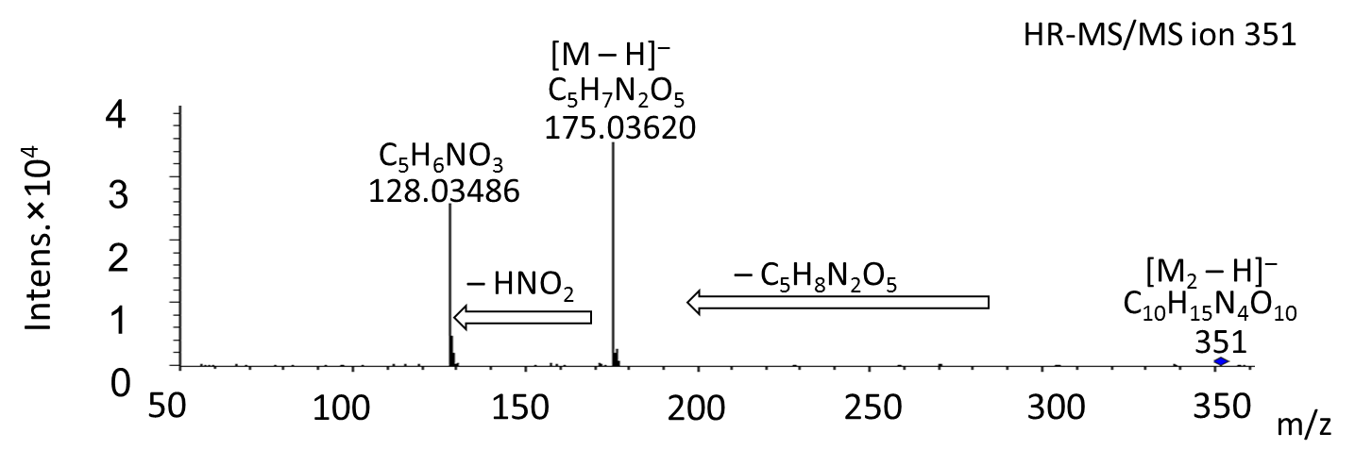
Fig. S1. HR-MS/MS of ion 351.

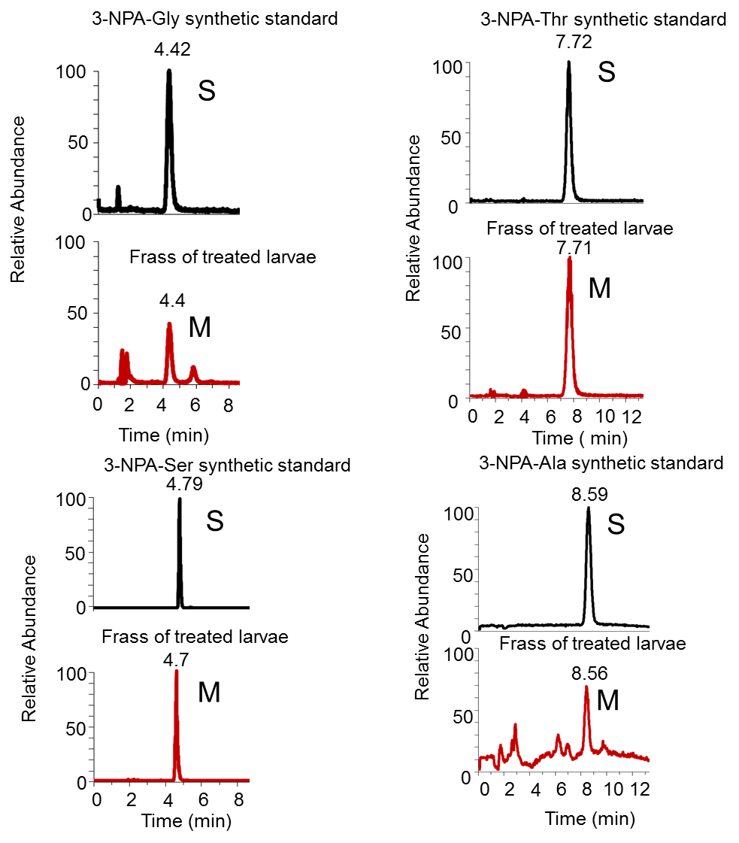
Fig. S2. Comparison of feces of 6th instar larvae treated with 3-NPA and synthetic amino acid amides.
(S- synthetic standard, M- metabolite).
Appendix II
¹H-,¹³C NMR- and IR-spectra of compounds 1-4

