Supporting Information for
Tetranorsesquiterpenoids as attractants of yucca moths to yucca flowers
Armin Tröger^{,1}, Glenn P. Svensson², Hans-Martin Galbrecht¹, Robert Twele¹, Joseph M. Patt³, Stefan Bartram⁴, Paulo H. G. Zarbin⁵, Kari A. Segraves⁶, David M. Althoff⁶, Stephan von Reuss^{1,7}, Robert A. Raguso*^{,8}, Wittko Francke^{1†}

(1) Institute of Organic Chemistry, University of Hamburg, Martin-Luther-King-Platz 6, D-20146 Hamburg, Germany
(2) Department of Biology, Lund University, Solvegatan 37, SE-223 62 Lund, Sweden
(3) USDA-Agricultural Research Service, U.S. Horticultural Research Laboratory, 2001 South Rock Road, Fort Pierce, FL 34945 United States of America
(4) Department of Natural Product Biosynthesis, Max Planck Institute for Chemical Ecology, Hans-Knöll-Straße 8, D-07745 Jena, Germany
(5) Department of Chemistry, Federal University of Parana, 81531-990 Curitiba, PR, Brazil
(6) Department of Biology, Syracuse University, 107 College Place, Syracuse, NY 13244, United States of America
(7) Laboratory of Bioanalytical Chemistry, University of Neuchatel, Avenue de Bellevaux 51, CH-2000 Neuchatel, Switzerland
(8) Department of Neurobiology and Behavior, Cornell University, 215 Tower Road, Ithaca NY 14853 United States of America
*Corresponding author: rar229@cornell.edu
†Wittko Francke deceased on 27th of December 2020.

Content
Supporting tables | S2
Supporting figures | S5
Synthesis of Filamentolide (A1, A2) | S11
Synthesis of Filamentol (B1, B2) | S15
Synthesis of Filamental (C1, C2) | S20
Synthesis of Filamentone (D) | S21
Synthesis of reference compounds for the attempted identification of the C₁₁-terpenoid E1 | S23

Supporting tables and figures

Table S1. Information about the floral scent samples of Yucca species included in this study and their use in coupled gas chromatographic-electroantennographic (GC/EAD) analyses.
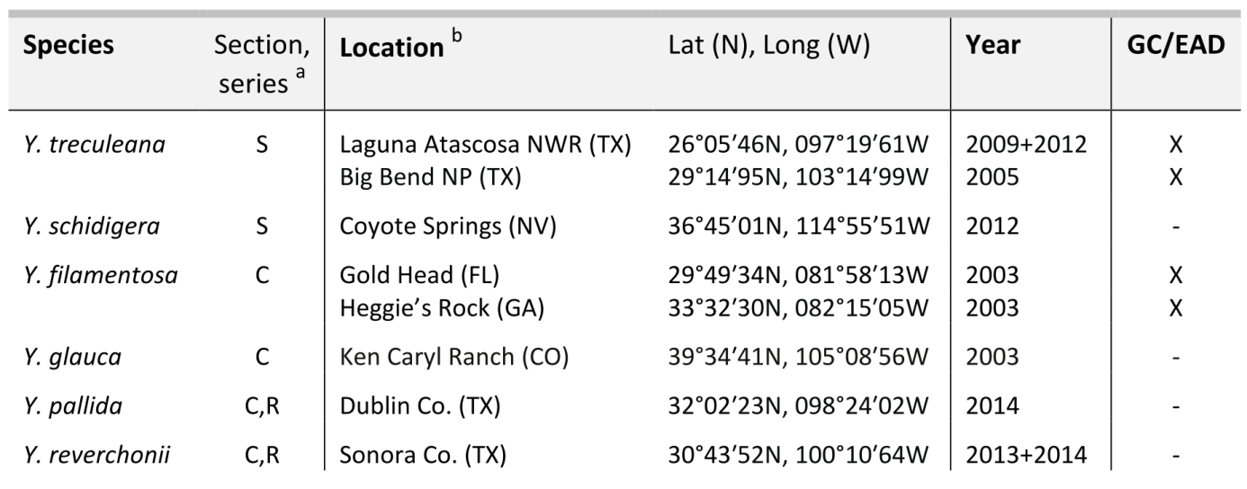
ª S: section Sarcocarpa; C: section Chaenocarpa; C,R: section Chaenocarpa, series Rupicolae.
^{b} Yucca pallida and Yucca reverchonii plants were transplanted and grown in a common garden at Syracuse University (NY).

Table S2. Moth species of the genera Prodoxus and Tegeticula used in the electrophysiological analyses of Yucca floral volatiles and locations for field collection of specimens.
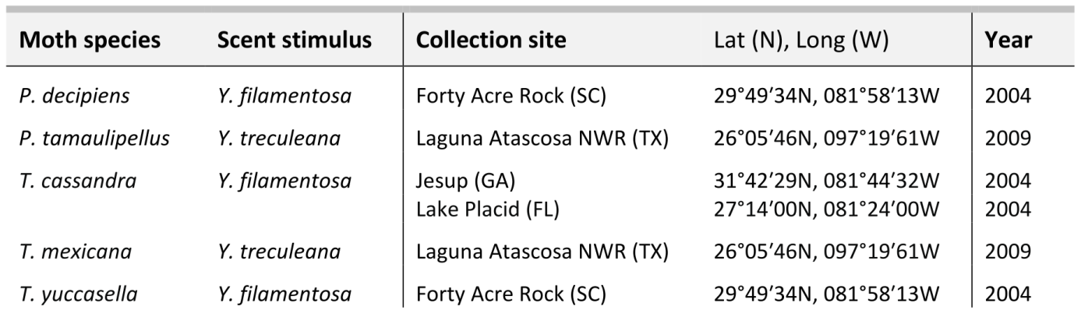

Table S3. Relative quantities of C₁₁-terpenoids and medium chain length hydrocarbons in the floral scents of Yucca treculeana, Yucca schidigera, Yucca filamentosa, Yucca glauca, Yucca pallida, and Yucca reverchonii: [rel%]: ••••• > 50, •••• > 20, ••• > 5, •• > 1, • < 1. * trace compound detected by DMDS derivatization. Elution order using HP-5 as the GC stationary phase.

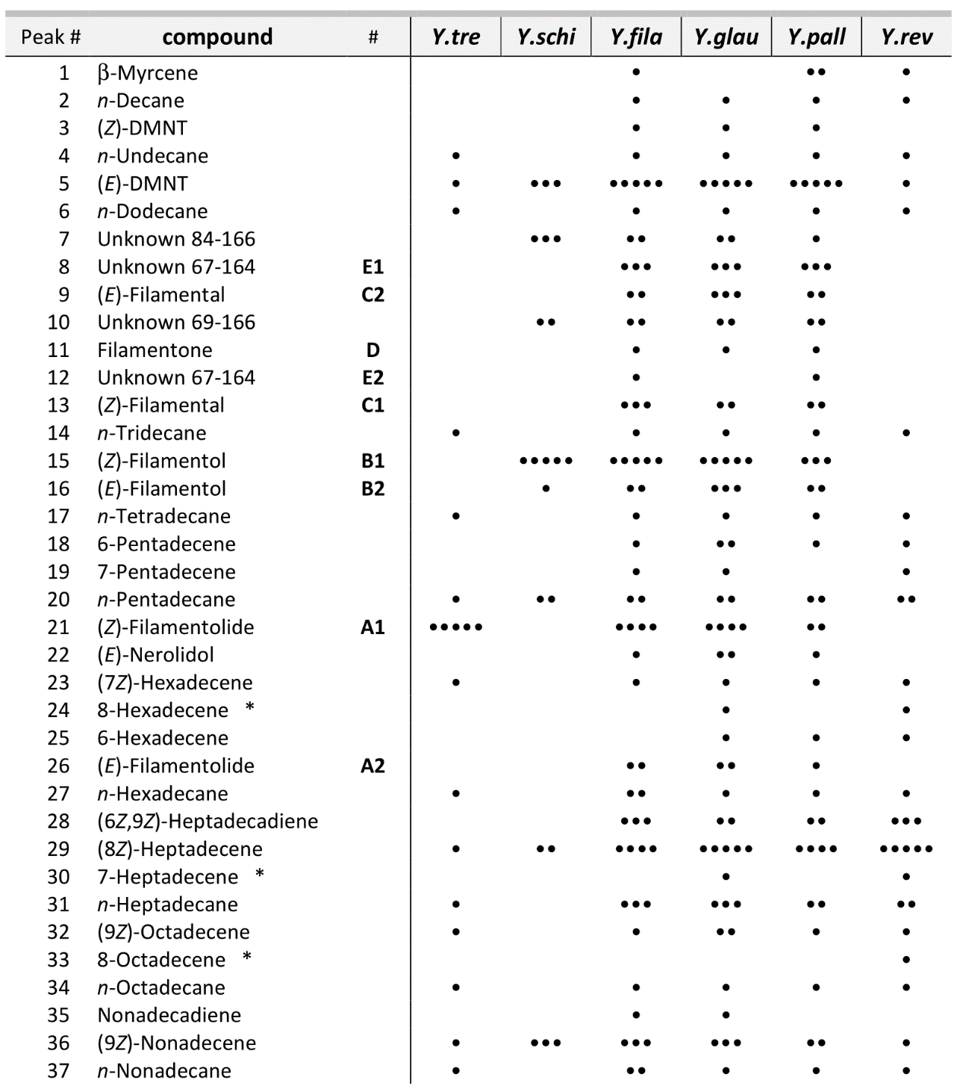

Supporting figures
Figure S1. TIC-chromatogram of a headspace sample from Yucca filamentosa flowers. Conditions: HP-5ms, 60 m × 0.25 mm i.d. × 0.25 µm film; temperature program 50/3-3-80-5-150-7-300/8. For peak assignment see Table S3.
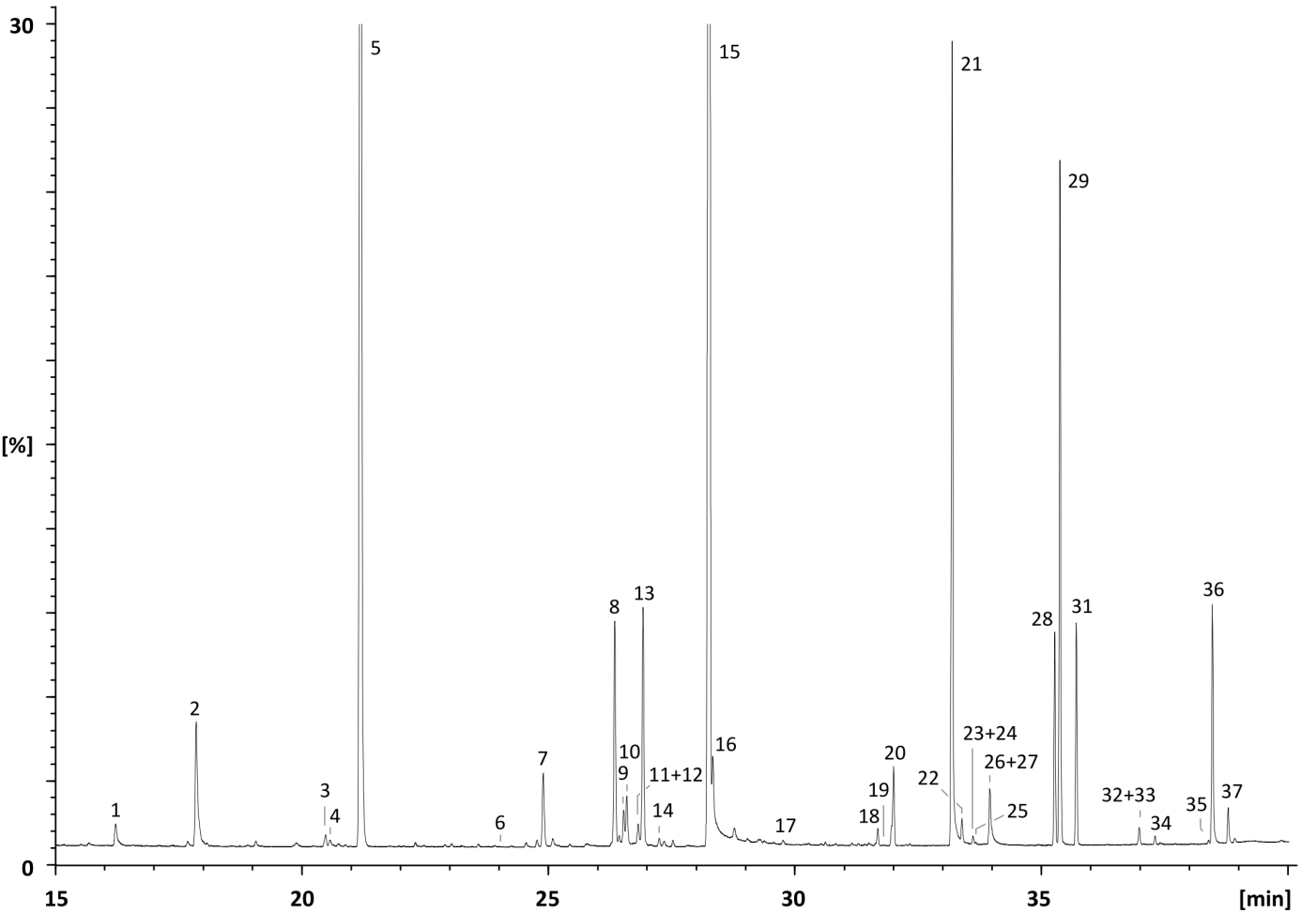

Figure S2. Assignment of the double bond configuration of (Z)-filamentolide (A1) by H,H-correlation in the NOESY spectrum.
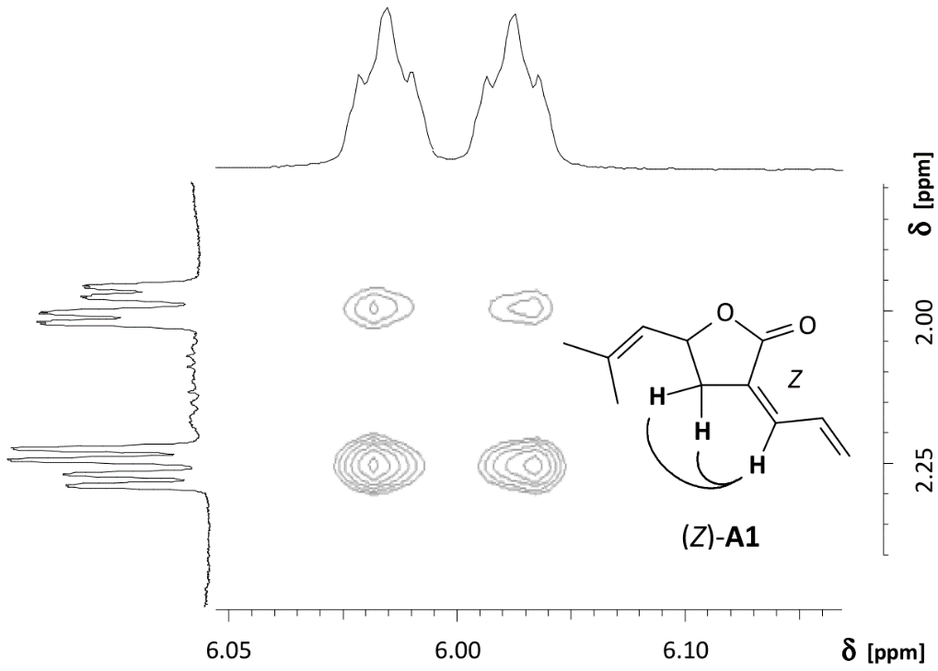

Figure S3. Determination of the absolute configuration of natural (R,Z)-filamentolide from Yucca spp. by comparative enantioselective GC/FID. (a) synthetic mixture of (Z,S)- and (Z,R)-filamentolide in a ratio of 2:1, (b) co-injection of racemic (Z)-filamentolide and floral headspace sample from Yucca treculeana, and (c) floral headspace sample from Y. treculeana. Conditions: heptakis-(6-O-tert-butyldimethylsilyl-2,3-di-O-methyl)-β-cyclodextrin, 25 m × 0.25 mm i.d. × 0.25 µm film; temperature program 120/30-10-150. α = 1.012 (tr_{5R}/tr_{5S}).
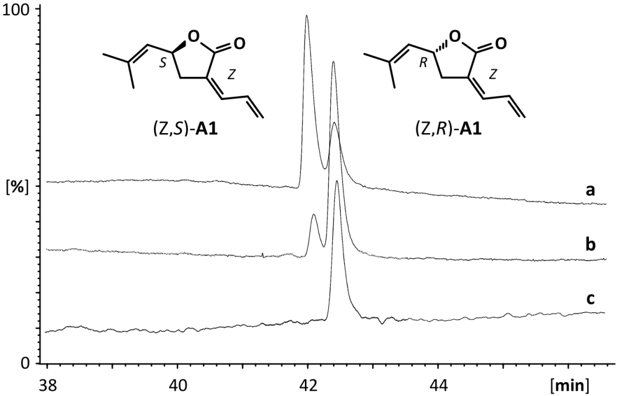

Figure S4. Assignment of the double bond configurations of (E)- and (Z)-filamentol (B2 and B1) by H,H-correlations in the NOESY spectra.
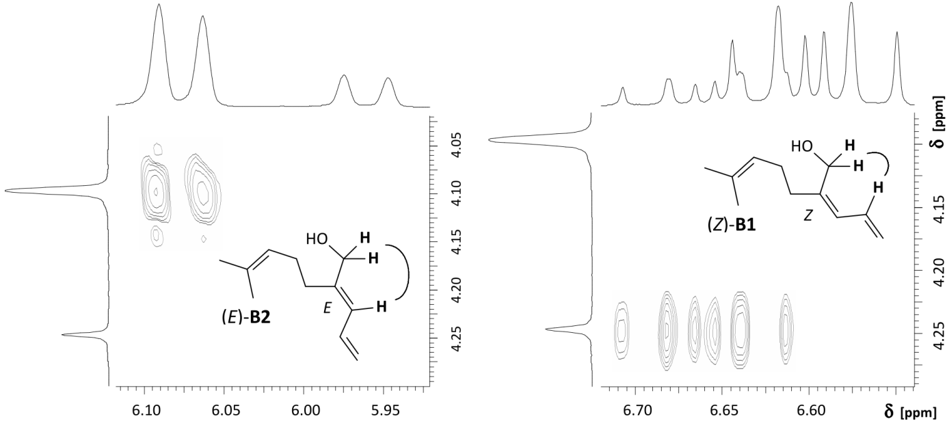

Figure S5. Assignment of the double bond configuration of (Z)-filamental (C1) by H,H-correlations in the NOESY spectrum.
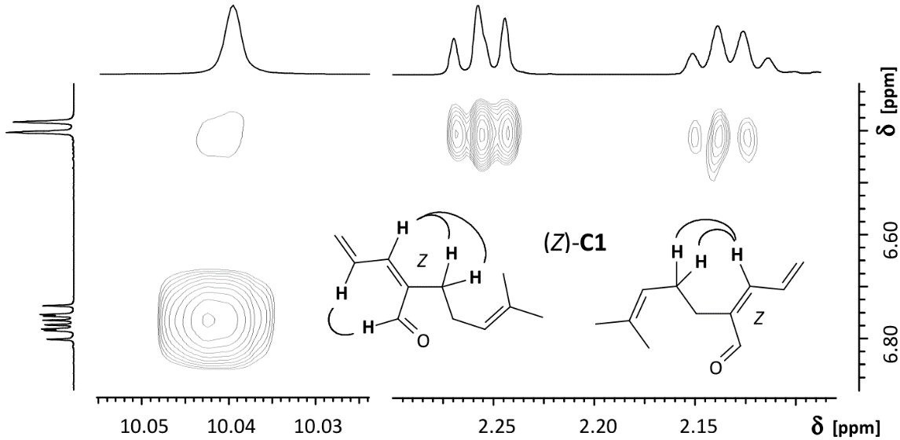

Figure S6. GC/FT-IR spectrum of the unidentified C₁₁-terpenoid E.
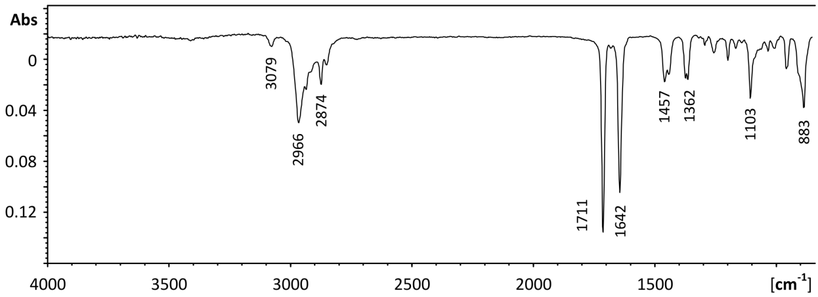

Synthesis of Authentic Standards
Reagents and solvents used for the synthesis of yucca volatiles were purchased from Sigma-Aldrich (Munich, Germany) and Merck (Darmstadt, Germany). Purification of reaction products was carried out by flash chromatography using MP Silica 60 Å, 32-63 mesh (MP Biomedicals Europe, Illkirch, France) under 0.5 bar pressure.
¹H NMR spectra, proton decoupled ¹³C NMR spectra, and two-dimensional H,H-COSY, HSQC, HMBC, and NOESY experiments were recorded at 25 °C using AVANCE 400 and DRX 500 instruments (Bruker Biospin, Rheinstetten, Germany) at the resonance frequencies indicated along with the experimental data. CDCl₃ and C₆D₆ were used as solvents for the deuterium lock. Signals for residual CHCl₃ or C₆HD₅ at δ_{H} 7.26 ppm and δ_{C} 77.1 ppm or at δ_{H} 7.16 ppm and δ_{C} 128.1 ppm, respectively, served as the internal standards. NMR data are reported as follows: δ chemical shift in ppm; multiplicity (s = singlet, d = doublet, t = triplet, q = quartet, m = multiplet); coupling constant(s) J in Hz; integral; assignment. Assignments are based on analysis of H,H-COSY, HSQC, HMBC, and NOESY data.
Optical rotations were measured in chloroform using a P8000 polarimeter (A. Krüss Optronic GmbH, Hamburg, Germany) equipped with a cuvette of 1 dm length. Measurements were carried out at a wavelength of λ = 589 nm and a temperature of 25 °C.

Synthesis of Filamentolide (A1, A2)
Figure S7. Synthesis of (Z)- and (E)-filamentolides (A1 and A2) and (b) synthesis of filamentols (B1 and B2), filamentals (C1 and C2), and filamentone (D). Conditions: i) DMP, py, DCM, -40 °C to RT, 1 h; ii) 1.: iPrPh₃PBr, n-BuLi, THF, -40 °C to RT, 1 h; 2.: (2), -90 °C to RT, 12 h; iii) 1.: LDA, THF, -80 °C, 1 h; 2.: MDPSCl, -80 °C to RT, 16 h; iv) 1.: LDA, THF, -80 °C, 45 min; 2.: acrolein, -80°C to RT, 30 min, reflux, 5 min.
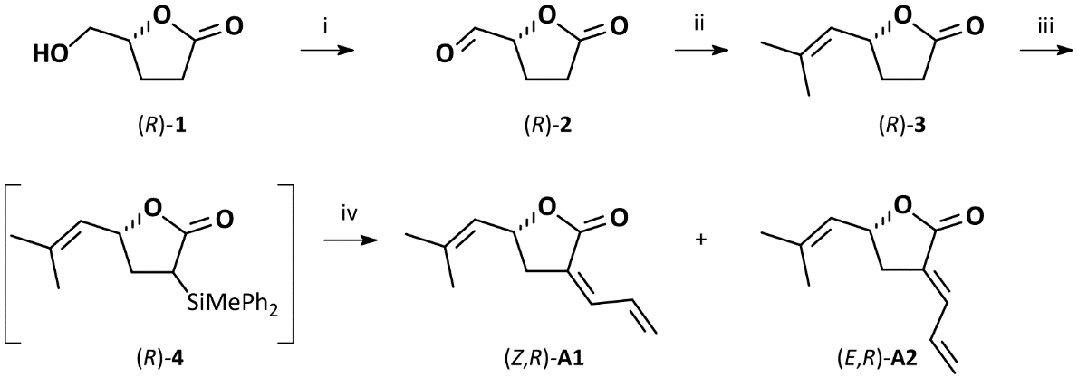

Synthesis of (2R)-5-Oxotetrahydrofuran-2-carbaldehyde ((R)-2)
Under argon atmosphere 2.1 mL dry pyridine (26.0 mmol) were added to a solution of 1.01 g (8.72 mmol) (R)-5-(hydroxymethyl)dihydrofuran-2(3H)-one ((R)-1) in 16 mL dry dichloromethane (DCM). After cooling to -40 °C the solution was treated portionwise with 4.06 g (9.58 mmol) 1,1,1-trisacetoxy-1,1-dihydro-1,2-benziodoxol-3(1H)-one (Dess-Martin periodinane, DMP) and stirred for 10 min. The reaction mixture was allowed to return to room temperature over the course of 1 h, monitoring the reaction progress by GC. The solution of the product, (2R)-5-oxotetrahydrofuran-2-carbaldehyde ((R)-2), was used immediately for the next step without any further purification.
MS (EI, 70 eV): m/z (%) = 37 (2), 38 (2), 39 (9), 40 (1), 41 (5), 42 (4), 43 (1), 44 (1), 45 (0.4), 49 (0.3), 50 (0.4), 51 (0.2), 53 (1), 55 (2), 56 (2), 57 (9), 58 (0.5), 68 (0.2), 69 (0.2), 85 (100), 86 (5), 87 (1), 114 (0.2) [M^{+●}].

Synthesis of (2S)-5-Oxotetrahydrofuran-2-carbaldehyde ((S)-2)
The synthesis of the enantiomeric (S)-aldehyde ((S)-2) was performed analogously to the (R)-isomer using 1.21 g (10.41 mmol) (S)-5-(hydroxymethyl)dihydrofuran-2(3H)-one ((S)-1), 2.4 mL (26.0 mmol) dry pyridine, and 4.80 g (11.32 mmol) 1,1,1-trisacetoxy-1,1-dihydro-1,2-benziodoxol-3(1H)-one (DMP). MS data were identical to those reported for the (R)-enantiomer.

Synthesis of (5R)-5-(2-Methylprop-1-en-1-yl)dihydrofuran-2(3H)-one ((R)-3)
Under argon atmosphere, a suspension of 19.30 g (42.6 mmol) isopropyltriphenylphosphonium bromide (85% purity) in 250 mL dry THF at -60 °C was treated dropwise with 26.5 mL (42.4 mmol) 1.6 M n-butyllithium solution in n-hexane. The solution was stirred at -60 °C for 20 min and at room temperature for 1 h. Subsequently the solution of the ylide was cooled to -90 °C, and the crude (2R)-5-oxotetrahydrofuran-2-carbaldehyde ((R)-2) solution was added dropwise. The suspension was warmed to room temperature and stirred overnight. The reaction was quenched with 3 mL saturated aqueous NH₄Cl solution. The resulting mixture was concentrated under reduced pressure to a volume of approximately 100 mL. This residue was taken up in 100 mL n-hexane, dried over MgSO₄, and filtered through 25 g silica gel. The eluate was concentrated under reduced pressure and washed four times with 8 mL saturated aqueous CuSO₄, twice with 8 mL saturated aqueous NaHCO₃, and once with 8 mL brine. Column chromatography on silica gel eluting with diethyl ether and pentane (3:1, v/v) afforded 501 mg (3.56 mmol, 41% over two steps) (5R)-5-(2-methylprop-1-en-1-yl)dihydrofuran-2(3H)-one ((R)-3) as a colorless oil (Rf = 0.16 (Pent/Et₂O 2:1 v/v)).
MS (EI, 70 eV): m/z (%) = 38 (4), 39 (38), 40 (6), 41 (37), 42 (7), 43 (6), 50 (4), 51 (6), 52 (3), 53 (13), 54 (5), 55 (19), 56 (38), 57 (7), 65 (4), 66 (2), 67 (8), 68 (2), 69 (9), 70 (2), 77 (4), 79 (11), 80 (2), 81 (26), 82 (2), 83 (15), 84 (2), 85 (31), 86 (2), 95 (3), 96 (2), 97 (12), 125 (100), 126 (8), 140 (25) [M^{+●}].
¹H NMR (400 MHz, CDCl₃): δ [ppm] = 1.73 (d, ⁴J_{H8-H6}=1.3 Hz, 3H, Z-CH₃ C9), 1.76 (d, ⁴J_{H8-H6}=1.3 Hz, 3H, E-CH₃ C8), 1.92 (dddd, ²J_{H4-H4}=12.8, ³J_{H4-H3}=9.6, 9.3, ³J_{H4-H5}=8.2 Hz, 1H, CH₂ C4), 2.35 (dddd, ²J_{H4-H4}=12.8, ³J_{H4-H3}=7.6, 5.6, ³J_{H4-H5}=6.4 Hz, 1H, CH₂ C4), 2.535 (dd, ³J_{H3-H4}=9.6, 7.6 Hz, 1H, CH₂ C3), 2.542 (dd, ³J_{H3-H4}=9.3, 5.6 Hz, 1H, CH₂ C3), 5.18 (ddd, ³J_{H5-H6}=8.7, ³J_{H5-H4}=8.2, 6.4 Hz, 1H, CH C5), 5.23 (dqq, ⁴J_{H6-H5}=8.7, ⁴J_{H6-H8}=1.3, 1.3 Hz, 1H, =CH C6).
¹³C NMR (101 MHz, C₆D₆): δ [ppm] = 18.5 (q, C9-Z), 25.8 (q, C8-E), 29.3 (t, C3), 29.4 (t, C4), 77.8 (d, C5), 122.9 (d, C6), 139.9 (s, C7), 177.3 (s, C2).

Synthesis of (5S)-5-(2-Methylprop-1-en-1-yl)dihydrofuran-2(3H)-one ((S)-3)
The synthesis of the enantiomeric (S)-isomer (S)-3 was performed analogously to its (R)-isomer using 20.03 g (46.33 mmol) isopropyltriphenylphosphonium bromide (85% purity) in 250 mL THF and 28.8 mL 1.6 M n-butyllithium (46.1 mmol). Column chromatography on silica gel furnished 513 mg (3.66 mmol, 35% yield over two steps) (5S)-5-(2-methylprop-1-en-1-yl)dihydrofuran-2(3H)-one ((S)-3) as a colorless oil, showing MS and NMR data identical to the (R)-enantiomer.

Synthesis of [3(6)E,5R]- and [3(6)Z,5R]-3-Allylidene-5-(2-methylprop-1-en-1-yl)dihydrofuran-2(3H)-one; (E,R)-Filamentolide ((E,R)-A2) and (Z,R)-Filamentolide ((Z,R)-A1)
A solution of 0.117 mL (84 mg, 0.83 mmol) diisopropylamine (freshly distilled over sodium) in 4 mL dry THF under argon atmosphere was cooled to -80 °C and treated with 0.50 mL (0.80 mmol) 1.6 M n-butyllithium in n-hexane. The solution was stirred at room temperature for 15 min. The resulting lithium disopropylamide (LDA) solution was added dropwise at -80 °C and under argon to a solution of 106 mg (0.76 mmol) (5R)-5-(2-methylprop-1-en-1-yl)dihydrofuran-2(3H)-one ((R)-3) in 15 mL dry THF. The solution was stirred at -80 °C for 1 h and subsequently treated with 160 μL (177 mg, 0.76 mmol) methyldiphenylsilyl chloride in 2 mL dry THF. After stirring at room temperature for 16 h the resulting solution of the (3RS,5R)-3-(methyldiphenylsilyl)-5-(2-methylprop-1-en-1-yl)dihydrofuran-2(3H)-one (4) was cooled to -80 °C and treated with freshly prepared LDA solution (from 0.15 mL (1.06 mmol) diisopropylamine in 4 mL THF und 0.50 mL (0.80 mmol) 1.6 M n-butyllithium in n-hexane). After stirring at -80 °C for 45 min, a solution of 55 μL (0.82 mmol) freshly distilled acrolein in 3 mL dry THF was added. The solution was stirred at -80 °C for 10 min, at room temperature for 15 min, and was heated under reflux for 10 min to complete the reaction.
For silylation of the byproduct methyldiphenylsilanol the mixture was cooled to -60 °C and treated with 0.4 mL (2.9 mmol) dry triethylamine, 5 mg (0.04 mmol) 4-dimethylaminopyridine, and 0.2 mL (1.58 mmol) trimethylsilyl chloride in 3 mL THF and stirred at room temperature for 30 min. The turbid mixture was cooled to 0 °C, diluted with 10 mL n-hexane, treated with 8 mL saturated aqueous NH₄Cl, and stirred for 10 min. The phases were separated and the aqueous phase was extracted with 8 mL diethyl ether. The combined organic phases were washed three times with 5 mL saturated aqueous NH₄Cl, once with 5 mL saturated aqueous NaHCO₃, and once with 5 mL brine, dried over sodium sulfate, filtered, and concentrated under reduced pressure. Column chromatography on silica gel eluting with diethyl ether and pentane (4 : 1, v/v) afforded 51 mg (0.29 mmol, 38% yield over 2 steps) [3(6)Z,5R]-3-allylidene-5-(2-methylprop-1-en-1-yl)dihydrofuran-2(3H)-one ((Z,R)-A1) and 41 mg (0.23 mmol, 30% yield over 2 steps) [3(6)E,5R]-3-allylidene-5-(2-methylprop-1-en-1-yl)dihydrofuran-2(3H)-one ((E,R)-A2) as colorless oils.
[3(6)Z,5R]-3-Allylidene-5-(2-methylprop-1-en-1-yl)dihydrofuran-2(3H)-one ((Z,R)-A1)
R_{f} = 0.45 (PE/Et₂O 4:1 v/v).
MS (EI, 70 eV): m/z (%) = 38 (5), 39 (60), 40 (23), 41 (47), 42 (4), 43 (7), 50 (5), 51 (11), 52 (5), 53 (10), 55 (11), 56 (3), 63 (7), 64 (2), 65 (25), 66 (100), 67 (17), 68 (2), 69 (11), 77 (13), 78 (4), 79 (11), 82 (3), 83 (11), 85 (12), 91 (34), 92 (5), 93 (9), 94 (33), 95 (5), 103 (2), 105 (11), 107 (3), 115 (5), 117 (11), 118 (3), 119 (5), 122 (2), 123 (2), 131 (3), 132 (4), 133 (18), 134 (3), 135 (29), 136 (7), 145 (4), 149 (5), 150 (6), 160 (7), 163 (5), 178 (9) [M^{+●}].
¹H NMR (600 MHz, C₆D₆): δ [ppm] = 1.35 (d, ⁴J_{H11-H9}=1.3 Hz, 3H, Z-CH₃ C12), 1.45 (d, ⁴J_{H11-H9}=1.3 Hz, 3H, E-CH₃ C11), 2.05 (ddd, ²J_{H4-H4}=16.9, ³J_{H4-H5}=6.6, ⁴J_{H4-H6}=2.2 Hz, 1H, CH₂ C4), 2.33 (ddd, ²J_{H4-H4}=16.9, ³J_{H4-H5}=7.3, ⁴J_{H4-H6}=1.8 Hz, 1H, CH₂ C4), 4.66 (ddd, ³J_{H5-H9}=8.8, ³J_{H5-H4}=7.3, 6.6 Hz, 1H, CH C5), 4.96 (dqq, ³J_{H9-H5}=8.8, ⁴J_{H9-H11}=1.30, 1.30 Hz, 1H, =CH C9), 5.17 (ddd, ³J_{H8-H7}=17.1, ²J_{H8-H8}=0.9, ⁴J_{H8-H6}=0.9 Hz, 1H, =CH-Z C8), 5.18 (ddd, ³J_{H8-H7}=9.9, ²J_{H8-H8}=0.9, ⁴J_{H8-H6}=0.9 Hz, 1H, =CH-E C8), 6.02 (brddd, ³J_{H6-H7}=11.3, ⁴J_{H6-H4}=2.2, 1.8 Hz, 1H, =CH C6), 8.14 (ddd, ³J_{H7-H8}=17.1, 9.9, ³J_{H7-H6}=11.3 Hz, 1H, =CH C7).
¹³C NMR (151 MHz, C₆D₆): δ [ppm] = 18.0 (q, C12-Z), 25.5 (q, C11-E), 36.3 (t, C4), 73.6 (d, C5), 123.8 (t, C8), 124.5 (d, C9), 125.9 (s, C3), 132.4 (d, C7), 138.0 (d, C6), 138.5 (s, C10), 168.9 (s, C2).

[3(6)E,5R]-3-Allylidene-5-(2-methylprop-1-en-1-yl)dihydrofuran-2(3H)-one ((E,R)-A2)
R_{f} = 0.27 (PE/Et₂O 4:1 v/v).
MS (EI, 70 eV): m/z (%) = 38 (7), 39 (73), 40 (25), 41 (39), 42 (3), 43 (3), 50 (5), 51 (11), 52 (5), 53 (9), 55 (10), 56 (3), 62 (2), 63 (7), 64 (2), 65 (25), 66 (100), 67 (14), 69 (9), 77 (9), 78 (3), 79 (5), 83 (10), 85 (8), 91 (13), 93 (5), 94 (21), 95 (3), 105 (2), 115 (2), 117 (2), 135 (2), 150 (10), 163 (2), 178 (6) [M^{+●}].
¹H NMR (400 MHz, C₆D₆): δ [ppm] = 1.36 (d, ⁴J_{H11-H9}=1.3 Hz, 3H, Z-CH₃ C12), 1.46 (d, ⁴J_{H11-H9}=1.3 Hz, 3H, E-CH₃ C11), 1.96 (ddd, ²J_{H4-H4}=17.4, ³J_{H4-H5}=6.3, ⁴J_{H4-H6}=3.0 Hz, 1H, CH₂ C4), 2.37 (ddd, ²J_{H4-H4}=17.4, ³J_{H4-H5}=7.8, ⁴J_{H4-H6}=2.5 Hz, 1H, CH₂ C4), 4.67 (ddd, ³J_{H5-H9}=8.8, ³J_{H5-H4}=7.8, 6.3 Hz, 1H, CH C5), 4.92 (dqq, ³J_{H9-H5}=8.8, ⁴J_{H9-H11}=1.3, 1.3 Hz, 1H, =CH C9), 5.14 (br.d, ³J_{H8-H7}=10.1 Hz, 1H, =CH-E C8), 5.20 (br.d, ³J_{H8-H7}=16.9 Hz, 1H, =CH-Z C8), 6.02 (ddd, ³J_{H7-H8}=16.9, 10.1, ³J_{H7-H6}=11.4 Hz, 1H, =CH C7), 7.14 (ddd, ³J_{H6-H7}=11.4, ⁴J_{H6-H4}=3.0, 2.5 Hz, 1H, =CH C6).
¹³C NMR (101 MHz, C₆D₆): δ [ppm] = 18.0 (q, C12-Z), 25.5 (q, C11-E), 32.6 (t, C4), 73.7 (d, C5), 124.7 (d, C9), 125.2 (t, C8), 128.2 (s, C3), 132.9 (d, C7), 134.4 (d, C6), 138.3 (s, C10), 170.5 (s, C2).

Synthesis of [3(6)E,5S]- and [3(6)Z,5S]-3-Allylidene-5-(2-methylprop-1-en-1-yl)dihydrofuran-2(3H)-one; (E,S)-Filamentolide ((E,S)-A2) and (Z,S)-Filamentolide ((Z,S)-A1)
The synthesis of both the (E,S)- and the (Z,S)-lactone (A) was performed analogously to the corresponding (R)-isomers starting from 494 mg (3.52 mmol) (5S)-5-(2-methylprop-1-en-1-yl)dihydrofuran-2(3H)-one ((S)-3) in 60 mL THF, which was deprotonated with LDA (from 0.55 mL (3.89 mmol) diisopropylamine in 10 mL THF and 2.4 mL (3.84 mmol) 1.6 M n-butyllithium), and treated with 0.75 mL (3.55 mmol) methyldiphenylsilyl chloride in 4 mL THF. The intermediate ((S)-4) was deprotonated with LDA (from 0.60 mL (4.25 mmol) diisopropylamine in 10 mL THF and 2.35 mL (3.76 mmol) 1.6 M n-butyllithium) and reacted with 0.26 mL (3.89 mmol) acrolein. The silanol was silylated using 0.90 mL (7.14 mmol) trimethylsilyl chloride in 6 mL THF with 1.6 mL (11.5 mmol) triethylamine and 22 mg (0.18 mmol) 4-dimethylaminopyridine. After workup, column chromatography on silica gel furnished 247 mg (1.39 mmol, 39% over two steps) [3(6)Z,5S]-3-allylidene-5-(2-methylprop-1-en-1-yl)dihydrofuran-2(3H)-one ((Z,S)-A1) and 73 mg (0.41 mmol, 12% yield over two steps) [3(6)E,5S]-3-allylidene-5-(2-methylprop-1-en-1-yl)dihydro-furan-2(3H)-one ((E,S)-A2) as colorless oils. The ratio of the double bond isomers was about (Z):(E) = 3:1. The specific rotation of the isolated (Z,S)-isomer of A1 was ${\left[α\right]}_{589}^{25}$ ${[α]}_{589}^{25}$= +37.8° (c = 2.0, CHCl₃). The MS and NMR data of (Z,S)-(A1) and (E,S)-(A2) were identical to those of the respective (R)-enantiomers.

Synthesis of Filamentol (B1, B2), Filamental (C1, C2), and Filamentone (D)
Figure S8. Synthesis of filamentol (B1 and B2), filamental (C1 and C2), and filamentone (D). Conditions: v) C₆H₁₁MgBr, CuI, TMEDA, Et₂O, -78 °C, 1.5 h; vi) LiAlH₄, Et₂O, -80 °C to RT, 12 h; vii) DMP, py, DCM -40 °C to RT, 12 h; viii) H₂CPPh₃, THF, -78 °C to RT, 12 h; ix) p-TsOH, MeOH, RT, 1 h; x) PCC, DCM, -20 °C to RT, 2 h.

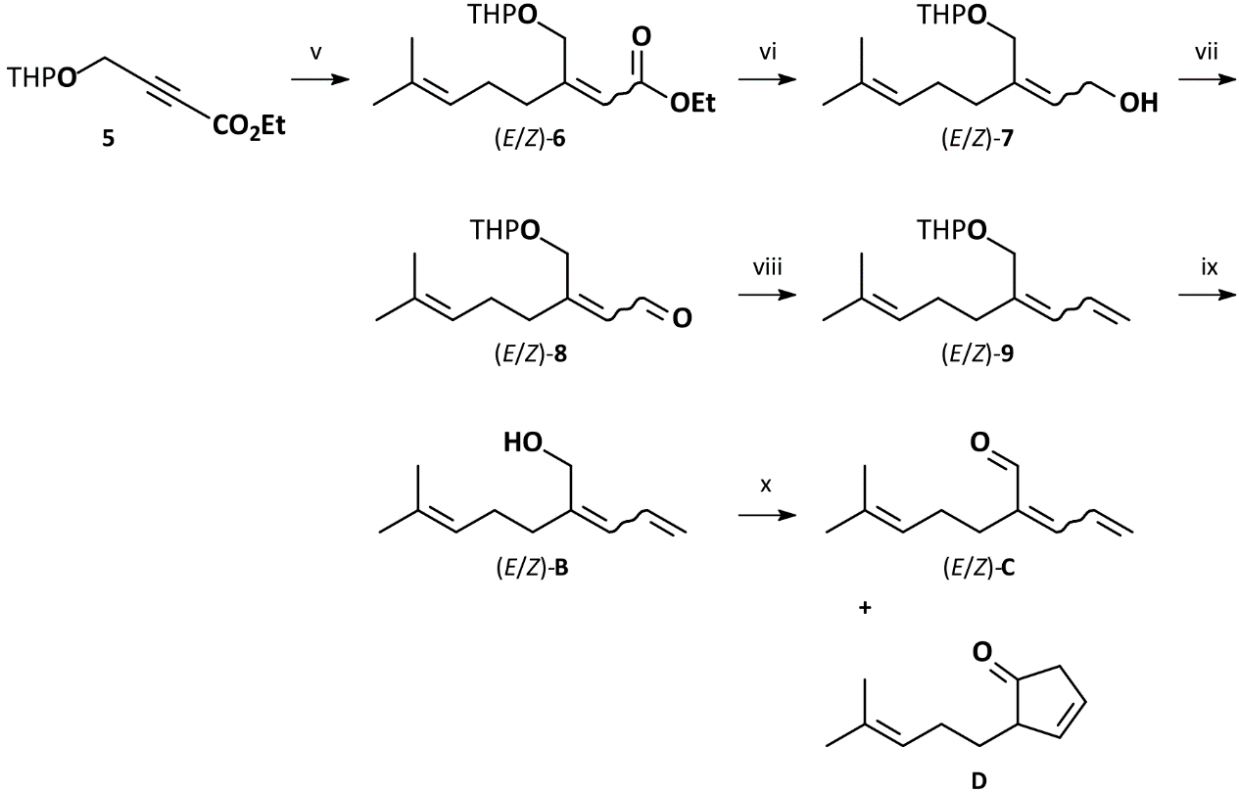

Synthesis of Filamentol (B1, B2)
Synthesis of Ethyl 4-(tetrahydro-2H-pyran-2-yloxy)but-2-ynoate (5)
A solution of 10.0 g (71.3 mmol) 2-(prop-2-ynyloxy)tetrahydro-2H-pyran in 100 mL dry tetrahydrofuran at -78 °C was treated with 37.7 mL (60.4 mmol) 1.6 M n-butyllithium in n-hexane. The solution was brought to room temperature over 1 h and stirred for 30 min. After renewed cooling to -78 °C, 5.2 mL (6.0 g, 54.9 mmol) ethyl chloroformate in 20 mL dry tetrahydrofuran were added slowly. The mixture was stirred at room temperature overnight and the reaction was subsequently quenched by addition of 100 mL saturated aqueous NH₄Cl. The aqueous phase was extracted four times with 50 mL diethyl ether. The combined organic phases were dried over MgSO₄, filtered, and concentrated under reduced pressure. Column chromatography on silica gel using a stepwise gradient of petrol ether and ethyl acetate (40:1, 35:1, 30:1, 25:1, 20:1, 15:1, 10:1, 5:1; v/v) furnished 8.92 g (42.0 mmol, 77% yield) ethyl 4-(tetrahydro-2H-pyran-2-yloxy)but-2-ynoate (5) as a colorless oil.
MS (EI, 70 eV): m/z (%) = 38 (12), 39 (25), 40 (26), 41 (50), 42 (10), 43 (23), 44 (9), 45 (6), 50 (3), 51 (4), 52 (5), 53 (20), 54 (12), 55 (70), 56 (39), 57 (20), 65 (5), 66 (47), 67 (48), 68 (14), 69 (9), 71 (5), 77 (4), 79 (5), 81 (13), 82 (10), 83 (30), 84 (26), 85 (100), 86 (8), 91 (3), 93 (4), 95 (4), 97 (9), 98 (10), 99 (5), 100 (4), 101 (17), 102 (2), 109 (21), 110 (8), 111 (71), 112 (44), 113 (10), 114 (3), 121 (3), 125 (5), 127 (5), 129 (11), 138 (4), 139 (5), 141 (3), 148 (1), 154 (6), 157 (12), 158 (3), 165 (2), 167 (6), 168 (2), 179 (1), 182 (2), 184 (1), 212 (not detected) [M^{+●}].
¹H NMR (400 MHz, CDCl₃): δ [ppm] = 1.26-1.31 (t, 3H, J=7.14 Hz, ethyl-CH₃), 1.48-1.58 (m, 2H, C4’-H_{a}, C5’-H_{a}), 1.58-1.68 (m, 2H, C3’-H_{a}, C5’-H_{b}), 1.69-1.78 (m, 1H, C3’-H_{b}), 1.78-1.88 (m, 1H, C4’-H_{b}), 3.53 (m, 1H, C6-H_{a}), 3.80 (m, 1H, C6-H_{b}), 4.18-4.25 (q, 2H, J= 7.14 Hz, ethyl-CH₂-), 4.35 (m, 2H, C4-H_{a}/H_{b}), 4.79 (m, 1H, C2’-H).
¹³C NMR (101 MHz, CDCl₃): δ [ppm] = 13.9 (s, ethyl-CH₃), 18.7 (s, C4’), 25.2 (s, C5’), 30.0 (s, C3’), 53.6 (s, C4), 61.9 (s, C6’), 62.0 (s, ethyl-CH₂-) 83.4 (s, C2), 77.6 (s, C2), 96.8 (s, C2’), 153.1 (s, C1).

Synthesis of (E/Z)-Ethyl 7-methyl-3-[(tetrahydro-2H-pyran-2-yloxy)methyl]octa-2,6-dienoate ((E/Z)-6)
A Grignard solution was prepared by adding 2.5 g (15.3 mmol) 5-bromo-2-methyl-2-pentene in 50 mL dry diethyl ether dropwise to a suspension of 373 mg (15.3 mmol) magnesium turnings in 20 mL dry diethyl ether. The mixture was refluxed for 2.5 h until all the magnesium had reacted to afford a grey turbid solution. Next, 2.92 g (15.3 mmol) dry copper (I) iodide in 100 mL dry diethyl ether were treated with 2.67 g (3.47 mL, 23.0 mmol) dry N,N,N’,N’-tetramethylethylendiamine (TMEDA) and cooled to -78 °C. The Grignard solution was added to the resulting beige-colored suspension over 10 min. After stirring for 2 h, a solution of 1.99 g (9.20 mmol) ethyl 4-(tetrahydro-2H-pyran-2-yloxy)but-2-ynoate (5) in 3 mL diethyl ether was added. After stirring for 1.5 h, the reaction was quenched by addition of 2.0 mL methanol and 150 ml saturated aqueous ammonium chloride / ammonia buffer (9:1, v/v). The aqueous phase was extracted three times with 25 mL diethyl ether, the combined organic phases were washed twice with 50 mL saturated aqueous ammonium chloride / ammonia buffer (9:1, v/v), once with 50 ml saturated brine, dried over MgSO_{4,} and concentrated under reduced pressure. Column chromatography on silica gel using a stepwise gradient of petrol ether and ethyl acetate (45:1, 40:1, 35:1, 30:1, 25:1, 20:1, 15:1, 10:1; v/v) furnished 3.09 g (10.4 mmol, 68% yield) of (E/Z) ethyl 7-methyl-3-[(tetrahydro-2H-pyran-2-yloxy)methyl]octa-2,6-dienoate ((E/Z)-6) as a colorless oil. The ratio of the double bond isomers was about (Z):(E) = 3:97.
MS (EI, 70 eV): m/z (%) = 39 (10), 40 (3), 41 (49), 42 (4), 43 (18), 44 (1), 45 (2), 51 (2), 52 (1), 53 (8), 54 (3), 55 (16), 56 (4), 57 (15), 65 (2), 67 (24), 68 (4), 69 (43), 70 (4), 77 (4), 78 (1), 79 (7), 80 (1), 81 (4), 83 (4), 84 (8), 85 (100), 86 (8), 91 (5), 93 (5), 94 (1), 95 (3), 96 (3), 97 (11), 98 (14), 99 (1), 105 (5), 106 (1), 107 (9), 108 (1), 109 (3), 110 (3), 111 (1), 119 (3), 120 (4), 121 (18), 122 (5), 123 (4), 124 (1), 125 (4), 126 (3), 133 (2), 137 (2), 138 (3), 139 (2), 143 (4), 144 (3), 147 (1), 148 (2), 149 (6), 151 (2), 165 (5), 166 (16), 167 (9), 168 (1), 179 (1), 181 (2), 194 (4), 195 (3), 212 (7), 213 (1), 296 (0.01) [M^{+●}].
¹H NMR (400 MHz, CDCl₃): δ [ppm] = 1.26-1.31 (t, 3H, J=7.15 Hz, ethyl-CH₃), 1.48-1.57 (m, 3H, C4’-H_{a}, C5’-H_{a}/H_{b}), 1.58-1.64 (m, 1H, C3’-H_{a}), 1.59-1.61 (s, 3H, C7-cis-CH₃), 1.66-1.69 (s, 3H, C8-CH₃), 1.69-1.76 (m, 1H, C3’-H_{b}), 1.77-1.86 (m, 1H, C4’-H_{b}), 2.14-2.23 (m, 2H, C5-H₂), 2.30-2.36 (m, 2H, C4-H₂), 3.48-3.56 (m, 1H, C6-H_{a}), 3.82-3.90 (m, 1H, C6-H_{b}), 4.10- 4.17 (q, 2H, J= 7.15 Hz, ethyl-CH₂-), 4.61-4.64 (m, 1H, C2’-H), 4.66-4.75 (m, 2H, C3-CH₂-O), 5.07-5.14 (m, 1H, C6-H), 5.69-5.73 (m, 1H, C2-H).
¹³C NMR (100 MHz, CDCl₃): δ [ppm] = 14.3 (s, ethyl-CH₃), 17.7 (s, C7-CH₃), 19.5 (s, C4’), 25.4 (s, C8), 26.6 (s, C5’), 28.7 (s, C4), 30.6 (s, C3’), 35.2 (s, C5), 59.8 (s, ethyl-CH₂-), 62.2 (s, C6’), 65.6 (s, C3-CH₂-O), 98.8 (s, C2’), 116.5 (s, C2), 123.3 (s, C6), 132.3 (s, C7), 159.7 (s, C3), 166.1 (s, C1).

Synthesis of (E/Z)-7-Methyl-3-[(tetrahydro-2H-pyran-2-yloxy)methyl]octa-2,6-dien-1-ol ((E/Z)-7)
A solution of 3.09 g (10.4 mmol) ethyl 7-methyl-3-[(tetrahydro-2H-pyran-2-yloxy)methyl]octa-2,6-dienoate ((E/Z)-6) in 30 mL dry diethyl ether was added to a suspension of 306 mg (8.08 mmol) LiAlH₄ in 50 mL dry diethyl ether at -78 °C. The suspension was stirred at room temperature overnight (18 h) after which an additional 197 mg (5.20 mmol) LiAlH₄ were added and the solution was refluxed for 6 h. The reaction was quenched by addition of 3.14 ml 4 M aqueous NaOH, the white precipitate was filtered off, and the residue was washed with diethyl ether. The combined organic phases were dried over MgSO₄, filtered, and concentrated under reduced pressure to furnish 2.32 g (9.12 mmol, 91% yield) (E/Z)-7-methyl-3-[(tetrahydro-2H-pyran-2-yloxy)methyl]octa-2,6-dien-1-ol ((E/Z)-7) as a colorless oil that was directly used for the next step. The ratio of the double bond isomers was about (Z):(E) = 4:96.
MS (EI, 70 eV): m/z (%) = 39 (11), 40 (3), 41 (50), 42 (4), 43 (40), 44 (2), 51 (2), 52 (1), 53 (7), 54 (2), 55 (12), 56 (3), 57 (13), 65 (4), 66 (2), 67 (25), 68 (2), 69 (23), 70 (2), 71 (2), 77 (3), 79 (4), 81 (7), 82 (4), 83 (4), 84 (4), 85 (100), 86 (6), 91 (4), 93 (2), 94 (1), 95 (26), 96 (12), 97 (3), 98 (1), 105 (2), 106 (2), 107 (5), 108 (2), 109 (3), 111 (2), 112 (2), 113 (8), 114 (2), 119 (1), 121 (6), 122 (2), 123 (6), 124 (3), 131 (1), 138 (5), 139 (7), 147 (3), 149 (11), 150 (1), 151 (4), 153 (5), 164 (20), 165 (5), 182 (9), 183 (1), 254 (not detected) [M^{+●}].
¹H NMR (400 MHz, CDCl₃): δ [ppm] = 1.49-1.60 (m, 4H, C3’-H_{a}, C4’-H_{a}, C5’-H_{a}/H_{b},), 1.59-1.61 (s, 3H, C7-cis-CH₃), 1.66-1.69 (s, 3H, C8-CH₃), 1.68-1.74 (m, 1H, C3’-H_{b}), 1.74-1.86 (m, 1H, C4’-H_{b}), 2.10-2.18 (m, 2H, C5-H₂), 2.20-2.26 (m, 2H, C4-H₂), 3.50-3.57 (m, 1H, C6-H_{a}), 3.80-3.89 (m, 1H, C6-H_{b}), 4.05- 4.22 (m, 4H, C1-H₂, C3-CH₂-O), 4.63-4.68 (m, 1H, C2’-H), 5.05-5.15 (m, 1H, C6-H), 5.68-5.74 (m, 1H, C2-H).
¹³C NMR (100 MHz, CDCl₃): δ [ppm] = 17.7 (s, C7-cis-CH₃), 19.1 (s, C4’), 25.3 (s, C5’), 25.7 (s, C8), 26.7 (s, C5), 30.4 (s, C3’), 35.5 (s, C4), 62.0 (s, C6’), 62.6 (s, C3-CH₂-O), 64.2 (s, C1), 97.0 (s, C2’), 123.7 (s, C6), 128.3 (s, C2), 131.6 (s, C7), 144.9 (s, C3).

Synthesis of (E/Z)-7-Methyl-3-[(tetrahydro-2H-pyran-2-yloxy)methyl]octa-2,6-dienal ((E/Z)-8)
A solution of 2.28 g (8.96 mmol) 7-methyl-3-[(tetrahydro-2H-pyran-2-yloxy)methyl]octa-2,6-dien-1-ol ((E/Z)-7) in 40 ml DCM was cooled to -40 °C and treated with 2.17 mL (26.9 mmol) pyridine and 4.18 g (9.85 mmol) 1,1,1-trisacetoxy-1,1-dihydro-1,2-benziodoxol-3(1H)-one (DMP). After stirring at room temperature overnight the suspension was washed twice with 20 mL saturated aqueous copper (II) sulfate and three times with 20 mL saturated brine. The wash solutions were extracted three times with 20 mL DCM each and subsequently the combined organic phases were washed three times with 20 mL saturated brine, dried over MgSO₄, filtered, and concentrated under reduced pressure. The crude product was used directly in the subsequent Wittig olefination. An analytical sample was obtained from an aliquot of 60 mg (1.5% of the crude product) by column chromatography on silica gel using a stepwise gradient of petrol ether and ethyl acetate (25:1, 20:1, 18:1, 16:1, 14:1, 12:1, 10:1, 8:1, 6:1; v/v) to furnish 11 mg (0.04 mmol) (E/Z)-7-methyl-3-[(tetrahydro-2H-pyran-2-yloxy)methyl]octa-2,6-dienal (8) as a colorless oil. The ratio of the double bond isomers was about (Z):(E) = 6:94.
MS (EI, 70 eV): m/z (%) = 38 (1), 39 (29), 40 (7), 41 (100), 42 (8), 43 (20), 44 (3), 45 (1), 50 (2), 51 (6), 52 (3), 53 (20), 54 (7), 55 (24), 56 (8), 57 (18), 59 (2), 65 (5), 66 (2), 67 (24), 68 (4), 69 (31), 70 (3), 71 (2), 73 (5), 77 (6), 78 (1), 79 (8), 80 (2), 81 (19), 82 (7), 83 (4), 84 (4), 85 (76), 86 (4), 91 (6), 92 (2), 93 (3), 94 (2), 95 (4), 97 (2), 98 (1), 99 (1), 101 (1), 105 (3), 107 (7), 108 (2), 109 (3), 110 (2), 112 (1), 117 (1), 121 (3), 122 (1), 123 (1), 125 (2), 133 (2), 135 (6), 137 (3), 139 (1), 147 (1), 149 (1), 150 (8), 151 (1), 167 (2), 168 (2), 252 (not detected) [M^{+●}].
¹H NMR (400 MHz, CDCl₃): δ [ppm] = 1.48-1.58 (m, 2H, C4’-H_{a}, C5’-H_{a}), 1.58-1.68 (m, 2H, C3’-H_{a}, C5’-H_{b} ), 1.55-1.58 (s, 3H, C7- cis-CH₃), 1.66-1.68 (s, 3H, C8-CH₃), 1.69-1.78 (m, 1H, C3’-H_{b}), 1.78-1.88 (m, 1H, C4’-H_{b}), 2.20-2.27 (m, 2H, C5-H₂), 2.49-2.58 (m, 2H, C4- H₂), 3.49-3.57 (m, 1H, C6-H_{a}), 3.79-3.84 (m, 1H, C6-H_{b}), 4.04-4.08 (m, 1H, C3-CH_{a}-O), 4.32-4.39 (m, 1H, C3-CH_{b}-O), 4.64-4.68 (m, 1H, C2’-H), 5.05-5.15 (m, 1H, C6-H), 6.14-6.19 (m, 1H, C2-H) , 9.97-10.00 (m, 1H, C1-H).
¹³C NMR (100 MHz, CDCl₃): δ [ppm] = 17.9 (s, C7-cis- CH₃), 19.0 (s, C4’), 25.3 (s, C5’), 25.8 (s, C8), 28.2 (s, C 4), 29.3 (s, C5), 30.2 (s, C3’), 62.0 (s, C6’), 68.8 (s, C3- CH₂-O), 98.3 (s, C2’), 122.3 (s, C6), 125.6 (s, C2), 134.0 (s, C7), 162.6 (s, C3), 191.0 (s, C1).

Synthesis of (E)- and (Z)-2-Allylidene-6-methylhept-5-en-1-ol, (E)- and (Z)-Filamentol (B2 and B1)
A solution of 9.60 g (26.9 mmol) methyltriphenylphosphonium bromide in 50 mL dry tetrahydrofuran at -78 °C was treated dropwise with 16.3 mL (26.0 mmol) 1.6 M n-butyllithium in n-hexane. The solution was stirred at room temperature for 30 min, cooled to -78 °C, and the crude (E/Z)-(7-methyl-3-[(tetrahydro-2H-pyran-2-yloxy)methyl]octa-2,6-dienal) ((E/Z)-8) in 10 mL THF was slowly added. After stirring at room temperature overnight the solvent was removed under reduced pressure and the residue was extracted five times with 20 mL petrol ether. The combined extracts were concentrated, and the crude olefination product 9 was dissolved in 25 ml methanol and treated with 50 mg (0.26 mmol) p-toluenesulfonic acid for 1 h at room temperature. The solution was concentrated under reduced pressure and the product isolated by chromatography on silica gel using a stepwise gradient of petrol ether and ethyl acetate (40:1, 35:1, 30:1, 25:1, 20:1, 15:1, 10:1, 5:1; v/v) to furnish 585 mg (3.52 mmol, 39% yield over three steps) (E/Z)-2-allylidene-6-methylhept-5-en-1-ol ((E/Z)-B) with an (E):(Z)-ratio of approximately 3:1. To separate the isomers, 50 mg of the mixture were submitted to column chromatography on silver nitrate impregnated silica gel (10%, w/w) using a stepwise gradient of petrol ether and ethyl acetate (40:1, 35:1, 30:1, 25:1, 20:1, 15:1, 10:1, 5:1; v/v) to furnish 12 mg (0.07 mmol) (E)-filamentol (B2) and 8 mg (0.05 mmol) of (Z)-filamentol (B1). The Z-configured filamentol was shown to be identical to the natural product B1 from Y. filamentosa.
(Z)-2-Allylidene-6-methylhept-5-en-1-ol, (Z)-filamentol (B1)
MS (EI, 70 eV): m/z (%) = 38 (1), 39 (14), 40 (3), 41 (63), 42 (3), 43 (6), 50 (1), 51 (3), 52 (2), 53 (8), 54 (2), 55 (8), 56 (1), 57 (1), 63 (1), 65 (5), 66 (2), 67 (14), 68 (4), 69 (100), 70 (9), 71 (1), 77 (8), 78 (2), 79 (15), 80 (4), 81 (3), 82 (5), 83 (3), 84 (1), 91 (5), 92 (3), 93 (2), 94 (8), 95 (5), 96 (4), 97 (3), 98 (1), 103 (1), 105 (4), 106 (1), 107 (2), 108 (1), 109 (2), 110 (2), 115 (1), 117 (1), 119 (1), 123 (3), 124 (1), 133 (2), 135 (1), 148 (1), 151 (2), 166 (1) [M^{+●}].
¹H NMR (600 MHz, C₆D₆): δ [ppm] = 1.60 (br. s., 3H, CH₃ C11), 1.68 (br. s., 3H, CH₃ C7), 2.18 (dt, ³J_{H4-H5}=11.6, ³J_{H4-H3}=5.8 Hz, 2H, CH₂ C4), 2.21 (t, ³J_{H3-H4}=5.8 Hz, 2H, CH₂ C3), 4.25 (s, 2H, CH₂ C1), 5.08 (dd, ³J_{H10-H9}=10.1, ²J_{H10-H10}=1.5 Hz, 1H, (E) =CHH C10), 5.03 (tspt, ³J_{H5-H4}=11.6, ⁴J_{H5-H7/11}=1.4 Hz, 1H, =CH C5), 5.19 (dd, ³J_{H10-H9}=16.7, ²J_{H10-H10}=1.5 Hz, 1H, (Z) =CHH C10), 5.96 (d, ³J_{H8-H9}=11.1 Hz, 1H, =CH C8), 6.66 (ddd, ³J_{H9-H10}=16.7, ³J_{H9-H8}=11.1, ³J_{H9-H10}=10.1 Hz, 1H, =CH C9).
¹³C NMR (151 MHz, C₆D₆): δ [ppm] = 17.8 (q, C11), 25.8 (q, C7), 27.0 (t, C3), 35.4 (t, C4), 60.6 (t, C1), 117.4 (t, C10), 123.9 (d, C5), 128.7 (d, C8), 132.2 (s, C6), 132.4 (d, C9), 141.4 (s, C2).

(E)-2-Allylidene-6-methylhept-5-en-1-ol, (E)-filamentol (B2)
MS (EI, 70 eV): m/z (%) = 38 (1), 39 (13), 40 (3), 41 (60), 42 (3), 43 (6), 50 (1), 51 (3), 52 (1), 53 (8), 54 (2), 55 (9), 56 (1), 57 (1), 63 (1), 65 (5), 66 (2), 67 (14), 68 (4), 69 (100), 70 (10), 71 (1), 77 (8), 78 (2), 79 (16), 80 (4), 81 (4), 82 (5), 83 (3), 84 (1), 85 (1), 91 (6), 92 (4), 93 (3), 94 (7), 95 (7), 96 (4), 97 (4), 98 (1), 103 (1), 105 (5), 106 (1), 107 (2), 108 (2), 109 (3), 110 (2), 111 (1), 115 (1), 117 (1), 119 (1), 120 (1), 123 (4), 124 (1), 133 (3), 135 (2), 148 (1), 151 (2), 166 (1) [M^{+●}].
¹H NMR (600 MHz, C₆D₆): δ [ppm] = 1.59 (br. s, 3H, CH₃ C11), 1.67 (d, ⁴J_{H7-H5}=1.4 Hz, 3H, CH₃ C7), 2.11 (td, ³J_{H4-H3}=7.7, ³J_{H4-H5}=7.7 Hz, 2H, CH₂ C4), 2.23 (t, ³J_{H3-H4}=7.7 Hz, 2H, CH₂ C3), 4.10 (s, 2H, CH₂ C1), 5.10 (dd, ³J_{H10-H9}=10.1, ²J_{H10-H10}=1.5 Hz, 1H, (E) =CHH C10), 5.11 (tspt, ³J_{H5-H4}=7.7, ⁴J_{H5-H7/11}=1.4 Hz, 1H, =CH C5), 5.21 (dd, ³J_{H10-H9}=16.7, ²J_{H10-H10}=1.5 Hz, 1H, (Z) =CHH C10), 6.08 (d, ³J_{H8-H9}=11.1 Hz, 1H, =CH C8), 6.60 (ddd, ³J_{H9-H10}=16.7, ³J_{H9-H8}=11.1, ³J_{H9-H10}=10.1 Hz, 1H, =CH C9).
¹³C NMR (151 MHz, C₆D₆): δ [ppm] = 17.8 (q, C11), 25.8 (q, C7), 27.6 (t, C3), 28.8 (t, C4), 66.9 (t, C1), 117.3 (t, C10), 123.8 (d, C5), 126.1 (d, C8), 132.5 (s, C6), 132.5 (d, C9), 142.1 (s, C2).

Synthesis of Filamentals (C1 and C2)
Synthesis of (E)- and (Z)-2-Allylidene-6-methylhept-5-enal, (E)- and (Z)-Filamentals (C2 and C1)
To a solution of 50 mg (0.30 mmol) (E/Z)-2-allylidene-6-methylhept-5-en-1-ol ((E/Z)-B) in 10 ml dry DCM, 100 mg pulverized 4 Å molecular sieve were added. The mixture was cooled to -20 °C and treated portionwise with 78 mg (0.36 mmol) pyridinium chlorochromate, and returned to room temperature over 2 h. The mixture was diluted with 15 mL pentane, filtered through a pad of silica gel and concentrated under reduced pressure. Column chromatography on silica gel eluting with pentane and diethyl ether (30:1, v/v) yielded 33 mg (0.20 mmol, 67% yield) of (E/Z)-2-allylidene-6-methylhept-5-enal ((E/Z)-C) as a colorless oil. Under these conditions, isomer-enriched fractions were obtained for analytical characterization. Depending on the reaction time and temperature, an increasing proportion of the (E)-product was formed. The two isomers were shown to be identical to the natural products from Y. filamentosa, C1 and C2, and named filamentals.
(E)-2-Allylidene-6-methylhept-5-enal, (E)-filamental (C2)
MS (EI, 70 eV): m/z (%) = 38 (1), 39 (17), 40 (3), 41 (59), 42 (3), 43 (3), 50 (2), 51 (4), 52 (2), 53 (9), 54 (1), 55 (4), 57 (1), 59 (1), 62 (1), 63 (2), 64 (1), 65 (8), 66 (6), 67 (17), 68 (3), 69 (100), 70 (6), 72 (1), 77 (9), 78 (3), 79 (13), 80 (4), 81 (4), 82 (7), 83 (1), 85 (2), 91 (9), 92 (2), 93 (9), 94 (3), 95 (11), 96 (3), 103 (1), 104 (1), 105 (3), 106 (1), 107 (8), 108 (26), 109 (4), 115 (1), 116 (1), 117 (1), 119 (1), 120 (1), 121 (9), 122 (6), 123 (2), 131 (4), 132 (1), 133 (1), 135 (1), 136 (3), 146 (1), 149 (2), 164 (2) [M^{+●}].
¹H NMR (600 MHz, C₆D₆): δ [ppm] = 1.48 (br. s, 3H, CH₃ C11), 1.60 (d, ⁴J_{H7-H5}=1.4 Hz, 3H, CH₃ C7), 2.13 (td, ³J_{H4-H3}=7.7, ³J_{H4-H5}=7.4 Hz, 2H, CH₂ C4), 2.36 (t, ³J_{H3-H4}=7.7 Hz, 2H, CH₂ C3), 5.08 (dd, ³J_{H10-H9}=10.0, ²J_{H10-H10}=1.5 Hz, 1H, (E) =CHH C10), 5.12 (tspt, ³J_{H5-H4}=7.4, ⁴J_{H5-H7/11}=1.4 Hz, 1H, =CH C5), 5.16 (ddd, ³J_{H10-H9}=16.8, ³J_{H10-H10}=1.5, ⁴J_{H10-H8}=0.8 Hz, 1H, (Z) =CHH C10), 6.22 (d, ³J_{H8-H9}=11.2 Hz, 1H, =CH C8), 6.45 (ddd, ³J_{H9-H10}=16.8, ³J_{H9-H8}=11.2, ³J_{H9-H10}=10.0 Hz, 1H, =CH C9), 9.27 (s, 1H, CHO C1).
¹³C NMR (151 MHz, C₆D₆): δ [ppm] = 17.6 (q, C11), 24.7 (t, C3), 25.8 (q, C7), 27.9 (t, C4), 124.0 (d, C5), 125.0 (t, C10), 132.2 (d, C9), 132.5 (s, C6), 142.4 (s, C2), 147.7 (d, C8), 193.8 (d, C1).

(Z)-2-Allylidene-6-methylhept-5-enal, (Z)-filamental (C1)
MS (EI, 70 eV): m/z (%) = 38 (1), 39 (17), 40 (4), 41 (63), 42 (3), 43 (3), 50 (2), 51 (5), 52 (2), 53 (10), 54 (2), 55 (5), 62 (1), 63 (2), 64 (1), 65 (8), 66 (6), 67 (21), 68 (3), 69 (100), 70 (6), 72 (1), 77 (8), 78 (3), 79 (12), 80 (5), 81 (4), 82 (22), 83 (6), 84 (1), 85 (2), 91 (8), 92 (2), 93 (8), 94 (3), 95 (13), 96 (3), 103 (1), 104 (1), 105 (3), 106 (1), 107 (6), 108 (23), 109 (3), 115 (1), 116 (1), 117 (1), 119 (1), 120 (1), 121 (9), 122 (5), 123 (1), 131 (4), 133 (1), 135 (1), 136 (3), 146 (1), 149 (2), 164 (2) [M^{+●}].
¹H NMR (600 MHz, C₆D₆): δ [ppm] = 1.50 (br. s, 3H, CH₃ C11), 1.62 (d, ⁴J_{H7-H5}=1.3 Hz, 3H, CH₃ C7), 2.13 (td, ³J_{H4-H3}=7.7, ³J_{H4-H5}=7.7 Hz, 2H, CH₂ C4), 2.26 (t, ³J_{H3-H4}=7.7 Hz, 2H, CH₂ C3), 4.98 (dd, ³J_{H10-H9}=9.9, ²J_{H10-H10}=1.5 Hz, 1H, (E) =CHH C10), 5.02 (dd, ³J_{H10-H9}=16.5, ²J_{H10-H10}=1.5 Hz, 1H, (Z) =CHH C10), 5.12 (tqq, ³J_{H5-H4}=7.7, ⁴J_{H5-H7/11}=1.3 Hz, 1H, =CH C5), 6.40 (d, ³J_{H8-H9}=11.7 Hz, 1H, =CH C8), 6.77 (ddd, ³J_{H9-H10}=16.5, ³J_{H9-H8}=11.7, ³J_{H7-H5}=9.9 Hz, 1H, =CH C9), 10.04 (s, 1H, CHO C1).
¹³C NMR (151 MHz, C₆D₆): δ [ppm] = 17.5 (q, C11), 25.8 (q, C7), 27.8 (t, C4), 30.9 (t, C3), 123.7 (t, C10), 124.0 (d, C5), 130.1 (d, C9), 132.3 (s, C6), 139.7 (s, C2), 144.2 (d, C8), 189.3 (d, C1).

Synthesis of Filamentone (D)
Synthesis of (RS)-2-(4-Methylpent-3-en-1-yl)cyclopent-3-enone, Filamentone ((RS)-D)
The cyclic ketone D was formed as a by-product during pyridinium chlorochromate oxidation of filamentol (B) and was obtained by column chromatography on silica gel eluting with pentane and diethyl ether (30:1, v/v). From 50 mg (0.30 mmol) (E/Z)-filamentol ((E/Z)-B) oxidized with 119 mg (0.55 mmol) pyridinium chlorochromate following the above procedure, 6 mg (0.04 mmol) 2-(4-methylpent-3-en-1-yl)cyclopent-3-enone were isolated with a chemical purity of 60%, along with filamental. This ketone was shown to be identical to the natural product D from Y. filamentosa, and was named filamentone.
MS (EI, 70 eV): m/z (%) = 38 (1), 39 (10), 40 (2), 41 (28), 42 (2), 43 (1), 50 (1), 51 (3), 52 (2), 53 (7), 54 (2), 55 (8), 56 (1), 63 (1), 65 (4), 66 (3), 67 (13), 68 (2), 69 (27), 70 (3), 77 (4), 78 (1), 79 (5), 80 (2), 81 (3), 82 (100), 83 (33), 84 (2), 91 (3), 93 (2), 94 (1), 95 (8), 96 (2), 105 (1), 107 (1), 108 (1), 121 (1), 149 (1), 164 (2) [M^{+●}].
¹H NMR (600 MHz, C₆D₆): δ [ppm] = 1.41-1.49 / 1.61-1.70 (2m, 2H, CH₂, C6), 1.50 (br.s, 1H, CH₃, C11), 1.61 (br.s, 1H, CH₃, C10), 1.98 (dtqq, ³J_{H7-H8}=7.7, ³J_{H7-H6}=7.3, ⁵J_{H7-H10/11}=1.1, 1.1 Hz, 2H, C7), 2.48 (ddd, ⁴J_{H5-H3}=2.4, ³J_{H5-H4}=2.2, ⁴J_{H5-H2}=2.0 Hz, 1H, C5), 2.58 (ddddt, ³J_{H2-H6}=7.9, 5.3, ⁴J_{H2-H4}=2.4, ³J_{H2-H3}=2.2, ⁴J_{H2-H5}=2.0 Hz, 1H, C2), 5.01-5.13 (m, 1H, C8), 5.66 (ddt, ³J_{H4-H3}=7.2, ⁴J_{H4-H2}=2.4, ³J_{H4-H5}=2.2 Hz, 1H, C4), 5.74 (dtd, ³J_{H3-H4}=7.2, ⁴J_{H3-H5}=2.4, ³J_{H3-H2}=2.2 Hz, 1H, C3).
¹³C NMR (151 MHz, C₆D₆): δ [ppm] = 18.0 (q, C11), 25.4 (t, C7), 26.1 (q, C10), 30.4 (t, C6), 42.1 (t, C5), 51.1 (d, C2), 123.6 (d, C8), 127.2 (d, C4), 131.8 (s, C9), 133.1 (d, C3), 216.3 (s, C1).

Synthesis of reference compounds for the attempted identification of the C₁₁-terpenoid E1
Figure S9. Synthesis of the compounds 12-15 proposed for the unidentified C₁₁-terpenoid E1. Conditions: i) SeO₂, TBHP, DCM, RT, 24 h; ii) Me₂NNH₂, p-TsOH, CyHex, reflux, 4 h; iii) 1.: n-BuLi, THF, -70 °C, 40 min, 2.: iPrBr, -60 °C to RT, 14 h; iv) 1.: n-BuLi, THF, -70 °C, 45 min, 2.: acrolein, -60°C to RT, 16 h; v) 1 N HCl, aq. sat. NH₄Cl, pentane, RT, 12 h; vi) MsCl, TEA, DCM, -40 °C to RT, 2 h; vii) LDA, THF, -40 °C, 30 min, acrolein, -20 °C, 90 min; viii) CH₂PPh₃, THF, -40 °C to RT, 14 h; ix) SeO₂, CyHex/H₂O, 5:1, RT, 48 h.

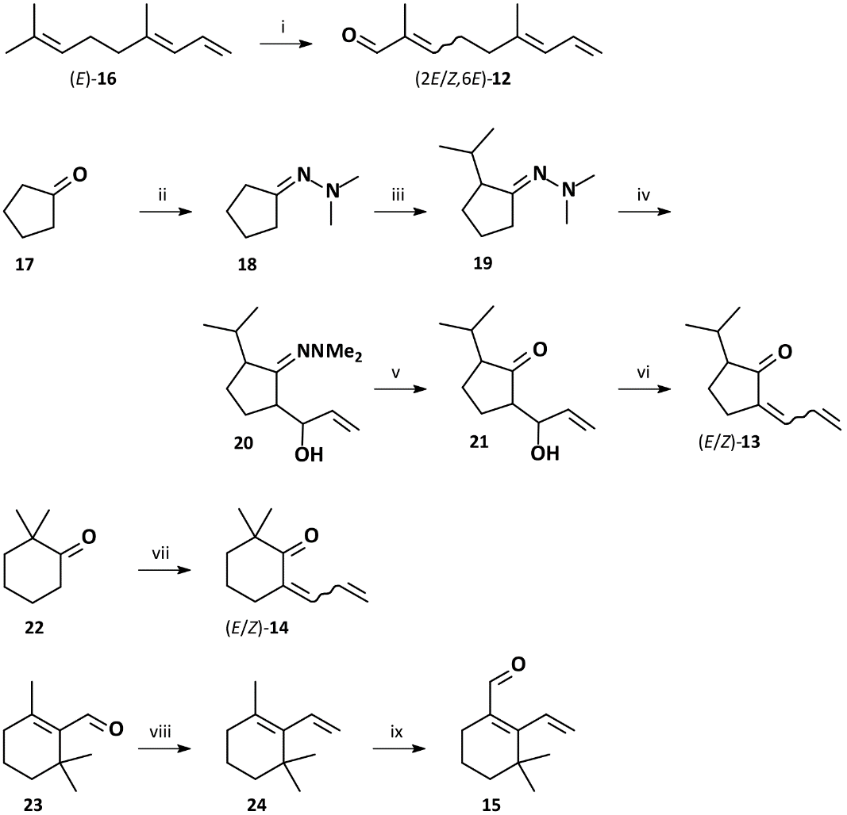

Synthesis of (2EZ,6E)-2,6-Dimethyl-2,6,8-nonatrienal (12)
A solution of 10 mg (0.067 mmol) synthetic (E)-4,8-dimethyl-1,3,7-nonatriene, (E)-DMNT (16) (Twele 2009) in 2 mL DCM was treated with 2 mg (0.018 mmol) freshly sublimated SeO₂ and 35 μL (0.256 mmol) 70% aqueous tert-butyl hydroperoxide (TBHP) solution. The reaction was stirred in the dark at room temperature for 48 h and subsequently quenched with 1 mL 5% aqueous HCl. The reaction mixture was extracted twice with 4 mL diethyl ether and the organic phase was washed with 3 mL saturated aqueous NaHCO₃ and 3 mL saturated brine, dried over MgSO₄, and filtered through a pad of silica gel. The concentrated extract was analyzed by GC/MS and shown to contain approximately 5% of the α,β-unsaturated aldehydes (10) as an 1:1 mixture of stereoisomers.

(2Z,6E)-2,6-Dimethyl-2,6,8-nonatrienal ((2Z,6E)-12)
MS (EI, 70 eV): m/z (%) = 38 (1), 39 (29), 40 (5), 41 (37), 42 (2), 43 (3), 50 (2), 51 (7), 52 (4), 53 (39), 54 (5), 55 (15), 56 (2), 63 (3), 65 (11), 66 (7), 67 (8), 68 (2), 69 (2), 77 (17), 78 (4), 79 (81), 80 (9), 81 (100), 82 (15), 83 (2), 84 (3), 91 (12), 92 (2), 93 (8), 94 (9), 95 (8), 96 (6), 105 (4), 106 (8), 107 (11), 108 (7), 109 (2), 115 (1), 120 (2), 121 (4), 122 (3), 123 (2), 131 (4), 134 (4), 135 (5), 136 (3), 149 (5), 164 (4) [M^{+●}].
(2E,6E)-2,6-Dimethyl-2,6,8-nonatrienal ((2E,6E)-12)
MS (EI, 70 eV): m/z (%) = 38 (1), 39 (20), 40 (4), 41 (27), 42 (1), 43 (2), 50 (2), 51 (5), 52 (3), 53 (28), 54 (4), 55 (11), 63 (2), 65 (8), 66 (5), 67 (5), 68 (1), 77 (12), 78 (2), 79 (59), 80 (6), 81 (100), 82 (10), 83 (2), 84 (1), 91 (6), 93 (3), 94 (2), 95 (2), 105 (2), 106 (2), 107 (4), 108 (2), 121 (3), 122 (6), 123 (1), 131 (2), 135 (3), 136 (1), 149 (11), 150 (1), 164 (3) [M^{+●}].

Synthesis of [2(6)EZ]-2-Allylidene-5-isopropylcyclopentanone (13)
Synthesis of Cyclopentanone-N,N-dimethylhydrazone (18)
A solution of 991 mg (11.78 mmol) freshly distilled cyclopentanone (17) and 1.0 mL (780 mg, 12.98 mmol) 1,1-dimethylhydrazine were dissolved in cyclohexane and treated with 20 mg (0.12 mmol) p-toluenesulfonic acid, and heated under reflux for 4 h using a Dean Stark apparatus. After cooling to RT, the yellowish solution was separated and treated with 20 ml saturated aqueous NaHCO₃ for 10 min. The organic phase was separated and washed three times with 6 mL saturated aqueous NaHCO₃, once with 6 mL saturated brine, dried over MgSO₄, and concentrated under reduced pressure. Distillation afforded 667 mg (5.29 mmol, 45% yield) cyclopentanone-N,N-dimethylhydrazone (18) as a colorless liquid.
MS (EI, 70 eV): m/z (%) = 38 (2), 39 (18), 40 (6), 41 (18), 42 (36), 43 (60), 44 (52), 45 (11), 46 (1), 50 (1), 51 (3), 52 (3), 53 (8), 54 (15), 55 (29), 56 (5), 57 (2), 58 (11), 59 (2), 65 (3), 66 (2), 67 (10), 68 (5), 69 (4), 70 (6), 71 (2), 72 (1), 80 (4), 81 (2), 82 (68), 83 (12), 84 (15), 85 (2), 96 (1), 97 (10), 111 (40), 112 (3), 125 (15), 126 (100) [M^{+●}], 127 (9).
¹H NMR (400 MHz, C₆D₆): δ [ppm] = 1.28-1.43 (m, 4H, 2×CH₂ C3 C4), 2.21-2.27 (m, 4H, 2×CH₂ C2 C5), 2.48 (s, 6H, 2×CH₃ C6 C7).

Synthesis of (EZ)-2-Isopropylcyclopentanone-N,N-dimethylhydrazone (19)
Under argon, a solution of 196 mg (1.55 mmol) cyclopentanone-N,N-dimethylhydrazone (18) in 20 mL dry THF at -80 °C was treated with 1.06 mL (1.68 mmol) 1.6 M n-butyllithium in n-hexane. After stirring at -70 °C for 45 min, a solution of 199 mg (1.62 mmol) freshly distilled isopropyl bromide in 2 mL THF was added dropwise. After stirring at room temperature for 16 h the resulting (EZ)-2-isopropylcyclopentanone-N,N-dimethylhydrazone (Z:E approximately 2:3) along with the dialkylated 2,5-diisopropylcyclopentanone-N,N-dimethylhydrazone (19) was directly used for the next step.
MS (EI, 70 eV): m/z (%) = 39 (16), 40 (3), 41 (33), 42 (26), 43 (35), 44 (65), 45 (36), 46 (6), 51 (3), 52 (3), 53 (10), 54 (14), 55 (36), 56 (5), 57 (2), 58 (9), 59 (6), 60 (3), 65 (7), 66 (4), 67 (13), 68 (4), 69 (6), 70 (6), 71 (3), 77 (4), 79 (5), 80 (7), 81 (8), 82 (79), 83 (13), 84 (38), 85 (7), 86 (11), 91 (2), 93 (2), 94 (7), 95 (4), 96 (6), 97 (4), 98 (2), 100 (2), 107 (1), 108 (5), 109 (5), 110 (8), 111 (10), 122 (2), 123 (3), 124 (8), 125 (100), 126 (68), 127 (5), 153 (11), 154 (1), 168 (69) [M^{+●}], 169 (8).

Synthesis of 2-(1-Hydroxy-2-propenyl)-5-isopropylcyclopentanone-N,N-dimethylhydrazone (20)
Under argon atmosphere, a solution of the (EZ)-2-isopropylcyclopentanone-N,N-dimethylhydrazone (19) in THF at -80 °C was treated with 1.05 mL (1.68 mmol) 1.6 M n-butyllithium in n-hexane. After stirring at -70 °C for 45 min, a solution of 97 mg (1.73 mmol) freshly distilled acrolein in 2 mL THF was added dropwise. After stirring at room temperature for 12 h the reaction was quenched by addition of 6 ml saturated aqueous NH₄Cl. The mixture was extracted twice with 10 mL pentane, and the organic phase was separated and washed three times with 6 mL saturated aqueous NaHCO₃, and once with 6 ml saturated brine. The solution was dried over MgSO₄, filtered through a pad of silica gel and concentrated under reduced pressure. GC/EI-MS analysis indicated a mixture of the target compound (20, 2 isomers, 3:4 with almost identical MS spectra) along with the monoalkylated, dialkylated, and monoaldol products. The mixture was used directly for the next step.
MS (EI, 70 eV): m/z (%) = 38 (1), 39 (16), 40 (4), 41 (36), 42 (30), 43 (38), 44 (100), 45 (46), 46 (47), 47 (1), 51 (3), 52 (3), 53 (16), 54 (20), 55 (54), 56 (11), 57 (16), 58 (8), 59 (8), 60 (2), 63 (1), 64 (1), 65 (11), 66 (6), 67 (19), 68 (11), 69 (11), 70 (11), 71 (7), 72 (5), 77 (11), 78 (3), 79 (21), 80 (16), 81 (38), 82 (78), 83 (48), 84 (22), 85 (6), 86 (8), 91 (11), 92 (5), 93 (7), 94 (13), 95 (11), 96 (13), 97 (9), 98 (3), 100 (1), 103 (1), 105 (4), 106 (5), 107 (12), 108 (19), 109 (19), 110 (11), 111 (5), 112 (1), 117 (3), 118 (9), 119 (8), 120 (10), 121 (4), 122 (10), 123 (12), 124 (39), 125 (38), 126 (34), 127 (3), 132 (1), 133 (1), 134 (2), 135 (2), 136 (8), 137 (16), 138 (5), 139 (2), 146 (2), 147 (1), 148 (2), 149 (1), 150 (2), 151 (2), 152 (4), 153 (8), 154 (3), 160 (1), 161 (2), 162 (6), 163 (3), 164 (3), 165 (1), 166 (1), 167 (46), 168 (41), 169 (4), 178 (2), 179 (1), 180 (34), 181 (9), 182 (2), 196 (2), 197 (2), 205 (13), 206 (8), 207 (2), 209 (3), 224 (13), [M^{+●}], 225 (2).

Synthesis of 2-(1-Hydroxy-2-propenyl)-5-isopropylcyclopentanone (21)
For the hydrolysis of the hydrazones (20) the crude mixture dissolved in 30 mL of a 5:1 mixture of pentane and THF was mixed with 20 mL saturated aqueous NH₄Cl solution and 1 mL 1 M HCl and stirred at room temperature for 12 h. The organic phase was separated and washed three times with 6 ml saturated aqueous NaHCO₃ and once with 6 ml saturated brine, dried over MgSO₄, filtered through a small pad of silica gel, and concentrated under reduced pressure. GC/EI-MS analysis indicated a mixture of the target compound (21, three isomers, 20:1:2 with identical MS spectra) along with the monoalkylated, dialkylated, and monoaldol products. The mixture was used directly for the next step.
MS (EI, 70 eV): m/z (%) = 37 (1), 38 (2), 39 (22), 40 (5), 41 (32), 42 (9), 43 (13), 44 (1), 50 (2), 51 (4), 52 (2), 53 (11), 54 (5), 55 (73), 56 (20), 57 (23), 58 (1), 63 (1), 65 (5), 66 (7), 67 (16), 68 (4), 69 (22), 70 (12), 71 (2), 77 (6), 78 (2), 79 (12), 80 (11), 81 (22), 82 (30), 83 (81), 84 (100), 85 (7), 87 (24), 88 (1), 91 (4), 93 (6), 94 (3), 95 (5), 96 (3), 97 (4), 99 (1), 102 (6), 107 (4), 108 (1), 109 (3), 111 (9), 112 (2), 121 (5), 122 (14), 123 (2), 125 (8), 126 (44), 127 (4), 136 (2), 139 (3), 140 (2), 164 (2), 182 (1) [M^{+●}].

Synthesis of [2(6)EZ]-2-Allylidene-5-isopropylcyclopentanone (13)
Under argon atmosphere, a mixture containing the 2-(1-hydroxy-2-propenyl)-5-isopropylcyclopentanone (21) in 10 mL dry DCM at -40 °C was treated with 0.9 mL (657 mg, 6.5 mmol) freshly distilled triethylamine and subsequently 120 µL (177 mg, 1.54 mmol) methanesulfonyl chloride in 2 mL dry DCM was added dropwise. After warming to room temperature over 2 h the dark orange solution was treated with 5 mL saturated aqueous NH₄Cl and stirred 10 min. The mixture was extracted twice with 10 mL pentane and the organic phase was washed three times with 6 mL saturated aqueous NH₄Cl, twice with 6 ml saturated aqueous NaHCO₃ and once with 6 ml saturated brine, dried over MgSO₄, filtered through a small pad of silica gel, and concentrated under reduced pressure. Column chromatography on silica gel eluting with pentane and diethyl ether (20:1, v/v) yielded 3 mg (0.02 mmol, 3% yield over five steps) of 2-allylidene-5-isopropylcyclopentanone (13) as a colorless oil.
MS (EI, 70 eV): m/z (%) = 39 (12), 40 (4), 41 (11), 43 (3), 50 (1), 51 (4), 52 (3), 53 (5), 55 (8), 63 (2), 65 (11), 66 (31), 67 (7), 69 (6), 77 (14), 78 (4), 79 (27), 80 (6), 81 (2), 91 (12), 92 (2), 93 (11), 94 (10), 95 (4), 103 (1), 105 (2), 107 (15), 108 (2), 119 (1), 120 (1), 121 (14), 122 (100), 123 (9), 149 (2), 164 (5) [M^{+●}].
¹H NMR (400 MHz, C₆D₆): δ [ppm] = 0.80 / 0.94 (2d, ³J_{H-H}=6.8 / 6.8 Hz, 6H, 2×CH₃ C10 C11), 1.21-1.30 / 1.47-1.58 (2m, 2H, CH₂ C4), 1.85 (ddd, ³J_{H-H}=10.8, 8.7, 5.3 Hz, 1H, CH C5), 1.93-2.04 (m, 1H, CH₂ C3), 2.17 (sptd, ³J_{H-H}=6.8, 1.8 Hz, 1H, CH C9), 2.30 (br.dd, ³J_{H-H}=17.3, 8.2 Hz, 1H, CH₂ C3), 5.19 (dddt, ³J_{H-H}=10.1, ²J_{H-H}=1.6, ⁴J_{H-H}=0.9, ⁶J_{H-H}=0.9 Hz, 1H, E-CH= C8), 5.26 (dd, ³J_{H-H}=16.9, ²J_{H-H}=1.6, ⁴J_{H-H}=0.9, ⁶J_{H-H}=0.9 Hz, 1H, Z-CH= C8), 6.24 (dddd, ³J_{H-H}=16.9, 11.4, 10.1, ⁵J_{H-H}=0.5 Hz, 1H, CH= C7), 7.09 (dtt, ³J_{H-H}=11.4, ⁴J_{H-H}=2.3, 0.9 Hz, 1H, CH= C6).
¹³C NMR (101 MHz, C₆D₆): δ [ppm] = 18.8 / 21.1 (2q, C10, C11), 22.2 (t, C4), 25.2 (t, C3), 28.1 (d, C9), 55.1 (d, C5), 125.4 (t, C8), 130.5 (d, C7), 133.4 (d, C6), 138.8 (s, C2).

Synthesis of 2-Allylidene-6,6-dimethylcyclohexanone (14)
Under argon, a LDA solution (from 646 mg (6.38 mmol) diisopropylamine in 20 mL THF and 2 ml (3.2 mmol) 1.6 M n-butyllithium in n-hexane) at -70 °C was treated with 206 mg (1.63 mmol) 2,2-dimethylcyclohexanone (22) in 3 mL THF. After 30 min at -45 °C a solution of 252 mg (4.50 mmol) acrolein in 3 mL THF were added. The reaction was allowed to warm to 0 °C over 90 min and subsequently quenched by addition of 6 ml saturated aqueous NH₄Cl and 10 mL pentane. The organic phase was separated and washed twice with 6 ml saturated aqueous NH₄Cl, twice with 6 mL saturated aqueous NaHCO₃, and once with 6 ml saturated brine. The solution was dried over MgSO₄, filtered through a pad of silica gel and concentrated under reduced pressure. Column chromatography on silica gel eluting with pentane and diethyl ether (20:1, v/v) yielded 40 mg (0.24 mmol, 15% yield) of 2-allylidene-6,6-dimethylcyclohexanone (14) as a colorless oil.
MS (EI, 70 eV): m/z (%) = 38 (1), 39 (22), 40 (7), 41 (26), 42 (3), 43 (3), 50 (3), 51 (8), 52 (8), 53 (10), 54 (2), 55 (12), 56 (1), 62 (1), 63 (4), 64 (1), 65 (15), 66 (16), 67 (16), 68 (3), 69 (23), 70 (3), 77 (24), 78 (7), 79 (51), 80 (10), 81 (7), 82 (3), 91 (17), 92 (3), 93 (55), 94 (13), 95 (16), 96 (2), 103 (2), 105 (5), 106 (2), 107 (36), 108 (14), 109 (3), 115 (1), 119 (1), 121 (100), 122 (10), 131 (1), 135 (1), 136 (68), 137 (7), 149 (3), 164 (7) [M^{+●}].
¹H NMR (400 MHz, C₆D₆): δ [ppm] = 1.07 (s, 6H, 2×CH₃ C10 C11), 1.34-1.41 (m, 4H, 2×CH₂ C4 C5), 2.21-2.27 (m, 2H, CH₂ C3), 5.16 (dddt, ³J_{H-H}=10.0, ²J_{H-H}=1.8, ⁴J_{H-H}=0.8, ⁶J_{H-H}=0.8 Hz, 1H, E-CH= C9), 5.27 (dddt, ³J_{H-H}=16.8, ²J_{H-H}=1.8, ⁴J_{H-H}=0.8, ⁶J_{H-H}=0.8 Hz, 1H, Z-CH= C9), 6.36 (ddd, ³J_{H-H}=16.8, 11.6, 10.0 Hz, 1H, CH= C8), 7.19 (dtt, ³J_{H-H}=11.6, 2.2, 0.8 Hz, 1H, CH= C7).
¹³C NMR (151 MHz, C₆D₆): δ [ppm] = 19.8 (t, C4), 26.4 (2q, C10, C11), 27.7 (t, C3), 38.3 (t, C5), 43.7 (s, C6), 124.3 (t, C9), 132.1 (d, C5), 134.9 (d, C7) 135.9 (s, C2) 204.7 (s, C1).

Synthesis of 1,3,3-Trimethyl-2-vinylcyclohex-1-ene („Cyclo-DMNT“) (24)
Under argon, a solution of 3.95 g (11.06 mmol) methyltriphenylphosphonium bromide in 50 mL dry THF at -40 °C was treated with 6.5 mL (10.4 mmol) 1.6 M n-butyllithium in n-hexane. After stirring at room temperature for 1 h the solution was cooled to -40 °C and treated with 1.01 g (6.63 mmol) freshly distilled β-cyclocitral (23) in 5 mL dry THF. After stirring at room temperature for 12 h the reaction was quenched by addition of 0.1 ml saturated aqueous NH₄Cl. The solution was dried over MgSO₄ and concentrated under reduced pressure. The residue was dissolved in 5 mL pentane and filtered through a pad of silica gel. Distillation at 400 mbar afforded 677 mg (4.51 mmol, 68% yield) 1,3,3-trimethyl-2-vinylcyclohex-1-ene (24) as a colorless oil.
MS (EI, 70 eV): m/z (%) = 39 (12), 40 (2), 41 (14), 43 (4), 50 (1), 51 (5), 52 (2), 53 (8), 55 (10), 57 (1), 63 (3), 65 (9), 66 (2), 67 (7), 69 (4), 77 (21), 78 (5), 79 (35), 80 (3), 81 (6), 91 (35), 92 (4), 93 (43), 94 (11), 95 (2), 103 (3), 104 (1), 105 (14), 106 (4), 107 (50), 108 (5), 115 (3), 117 (3), 119 (4), 120 (2), 121 (5), 122 (2), 123 (1), 135 (100), 136 (11), 150 (27) [M^{+●}], 151 (3).
¹H NMR (400 MHz, C₆D₆): δ [ppm] = 1.06 (s, 6H, 2×CH₃ C10 C11), 1.41-1.45 (m, 2H, CH₂ C4), 1.51-1.58 (m, 2H, CH₂ C5), 1.72 (dt, ⁵J_{H-H}=1.0, ⁴J_{H-H}=0.9 Hz, 3H, CH₃ C9), 1.90 (tdq, ³J_{H-H}=6.4, ⁵J_{H-H}=1.9, ⁴J_{H-H}=0.9 Hz, 2H, CH₂ C6), 5.02 (dd, ³J_{H-H}=17.6, ²J_{H-H}=2.8 Hz, 1H, Z-CH= C8), 5.24 (dd, ³J_{H-H}=11.1, ²J_{H-H}=2.8 Hz, 1H, E-CH= C8), 6.24 (ddtq, ³J_{H-H}=17.6, 11.1, ⁵J_{H-H}=1.9, 1.0 Hz, 1H, CH= C7).
¹³C NMR (101 MHz, C₆D₆): δ [ppm] = 19.3 (t, C5), 21.2 (q, C9), 28.5 (2q, C10, C11), 32.5 (t, C6), 33.6 (s, C3), 39.4 (t, C4), 117.9 (t, C8), 128.2 (s, C1), 135.5 (d, C7), 138.3 (s, C2).

Synthesis of 3,3-Dimethyl-2-vinylcyclohex-1-en-1-carbaldehyde (15)
A solution of 168 mg (1.12 mmol) 1,3,3-trimethyl-2-vinylcyclohex-1-ene (24) in 12 mL of a dioxane/ water mixture (5:1, v/v) was treated with 266 mg (2.40 mmol) freshly sublimated SeO₂ and stirred in darkness for 48 h. The reaction was quenched by addition of 10 mL saturated aqueous NaHCO₃ and the mixture was extracted three times with 6 mL diethyl ether. The combined organic phase was dried over MgSO₄, filtered through a small pad of silica, concentrated under reduced pressure, and used directly for the next step.
91 mg of the crude mixture in 10 mL dry DCM at -20 °C was treated portionwise with 275 mg (0.65 mg) 1,1,1-trisacetoxy-1,1-dihydro-1,2-benziodoxol-3(1H)-one (DMP). The solution was stirred for 45 min until it reached room temperature and quenched by addition of 5 ml saturated aqueous NaHCO₃. The mixture was concentrated under reduced pressure and extracted three times with 5 mL pentane / diethyl ether (1:1, v/v). The combined organic extracts were dried over MgSO₄, filtered, and concentrated under reduced pressure. The target compound (15) was detected by GC/EI-MS as a minor product (1.5% of the crude).
MS (EI, 70 eV): m/z (%) = 38 (3), 39 (29), 40 (5), 41 (31), 42 (3), 43 (11), 50 (6), 51 (18), 52 (9), 53 (19), 54 (3), 55 (21), 56 (3), 57 (1), 58 (1), 59 (1), 62 (3), 63 (9), 64 (4), 65 (22), 66 (8), 67 (18), 68 (3), 69 (10), 70 (2), 71 (5), 74 (2), 75 (2), 76 (2), 77 (51), 78 (13), 79 (63), 80 (21), 81 (22), 82 (5), 83 (4), 84 (1), 87 (1), 89 (3), 90 (2), 91 (76), 92 (12), 93 (97), 94 (24), 95 (29), 96 (6), 97 (2), 98 (2), 102 (2), 103 (10), 104 (4), 105 (32), 106 (7), 107 (71), 108 (66), 109 (14), 110 (1), 111 (2), 113 (2), 115 (9), 116 (5), 117 (4), 118 (2), 119 (11), 120 (7), 121 (83), 122 (17), 123 (3), 124 (1), 125 (2), 127 (1), 128 (1), 129 (3), 130 (1), 131 (17), 132 (3), 133 (12), 134 (3), 135 (11), 136 (17), 137 (3), 145 (2), 146 (2), 147 (4), 148 (10), 149 (98), 150 (11), 162 (2), 163 (40), 164 (100) [M^{+●}], 165 (13).

References
Twele R (2009) Identifizierung und Synthese verhaltensmodifizierender Signalstoffe aus Insekten und Pflanzen. Ph.D. dissertation, University of Hamburg, Hamburg, Germany.

