Two defensive lines in juvenile leaf beetles; esters of 3-nitropropionic acid in the hemolymph and aposematic warning

Authors and affiliations
Gerhard Pauls¹, Tobias Becker¹, Peter Rahfeld¹, Rene R. Gretscher¹, Christian Paetz², Jacques Pasteels³, Stephan H. von. Reuss¹, Antje Burse¹, Wilhelm Boland^{1*}
¹ Department of Bioorganic Chemistry, Max Planck Institute for Chemical Ecology, Jena, Germany
² Biosynthesis and Nuclear Magnetic Resonance Group, Max Planck Institute for Chemical Ecology, Jena, Germany
³ Université Libre de Bruxelles, Department of Biology

* Corresponding author: Phone: ++49(0)3641-571200, Fax: ++49(0)3641-571202, E-mail: boland@ice.mpg.de

For submission in the Journal of Chemical Ecology

Fig. S1 Mass spectra of isoxazoline-5-one-glucoside and isoxazoline-5-one-glucoside ester. Marked signals correspond to [M]⁻ and[M+HCOOH]⁻ ions

Fig. S2 Mass spectra of isoxazoline-5-one-glucoside ester before and after injection with [¹³C,¹⁵N]-3-NPA.
The signal intensity of m/z 395 corresponding to [M+HCOOH+2] ⁻ is increased, see Fig. S5 for labelling ratios of the investigated species
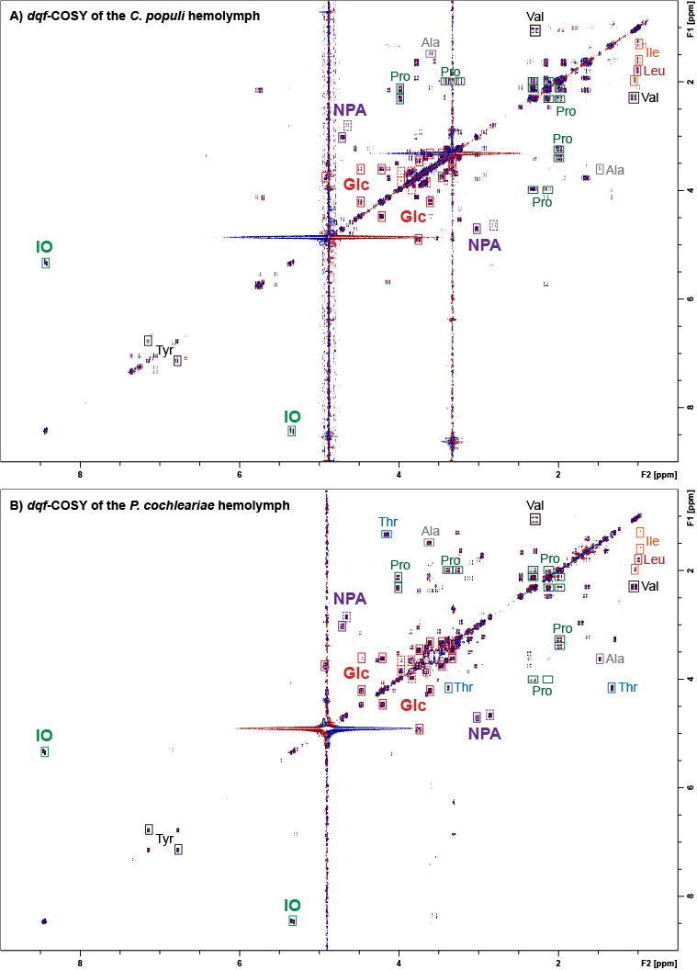
Fig. S3 Double quantum filtered (dqf)-COSY spectra (500 MHz, CD₃OD) of the crude hemolymph from Chrysomela populi (A) or Phaedon cochleariae (B). Signals corresponding to amino acids (three letter codes), as well as isoxazoline (IO), glucose (Glc), and 3-nitropropionate (NPA) units are labelled.

Fig. S4 Concentrations of isoxazolinone glucoside 5 and its 3-Nitropropionic acid ester 6 per mg body weight. The concentration of isoxazolinone glucoside (triangles) remained stable during development (regression analysis, P=0.448, F=0.593, N=30), the ester (dots) showed an increase in concentration (P<0.001, F=14.757, r²= 0.345, N=30), indicating autogenous synthesis

Fig. S5 [¹³C,¹⁵N]-enrichment of isoxazolin glucoside ester 6 upon injection with [¹³C,¹⁵N]-3-Nitropropionic acid. The enrichment of 6 upon incorporation of injected labelled 3-NPA was calculated based on the relative intensities of the isotopic signals (detected as formic acid adducts) by using the equation: [¹³C,¹⁵N]-6 in % = 100 / ([M+HCOO]⁻ L + [M+1+HCOO]⁻ L + [M+2+HCOO]⁻ L) * ([M+2+HCOO] ⁻ L - [M+2+HCOO] ⁻ C) with L representing the labelled compound and C the unlabelled control. The isotope enrichment for compound 6 in Chrysomela populi was 13.2 % ± 4,3% (mean value ± standard deviation, n=10 for each species), in the case of Phaedon cochleariae it was 7% ± 1,3%, while Chrysomela lapponica showed 24.5% ± 9,5% enrichment.
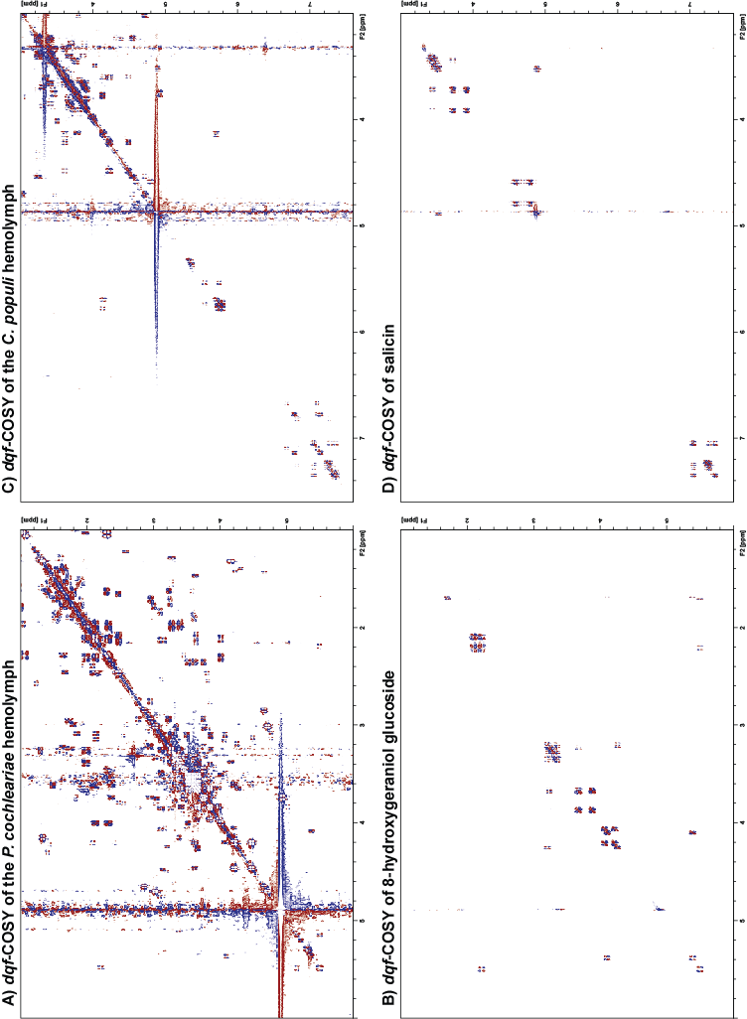
Fig. S6 NMR spectroscopic identification of 8-hydroxygeraniol glucoside and salicin. A: Partial dqf-COSY spectrum of the crude Phaedon cochleariae hemolymph; B: dqf-COSY spectrum of 8-hydroxygeraniol glucoside standard; C: Partial dqf-COSY spectrum of the crude Chrysomela populi hemolymph; D: dqf-COSY spectrum of salicin standard.

Tab. S1 Leaf beetle larvae analyzed for this study with collection site and host plant

 | 5 |  |  |  | 6
 | ¹H | COSY | ¹³C | HMBC | ¹H | COSY | ¹³C | HMBC
1 | 4.925 d | J_{1,2} = 9.2 | 90.4* | C-1’,  C-2,3,5 | 4.930 d | J_{1,2} = 9.2 | 90.2* | C-1’  C-2,3,5
2 | 3.746* | H-1’, H-3’ | 71.0* | C-1,3 | 3.746* | H-1’, H-3’ | 71.0* | C-1,3
3 | 3.457* | H-2’, H-4’ | 78.5* | C-2,4 | 3.457* | H-2’, H-4’ | 78.5* | C-2,4
4 | 3.326* | H-3’, H-5’ | 70.9 | C-3,5,6 | 3.326* | H-3’, H-5’ | 70.9 | C-3,5,6
5 | 3.407 ddd | J_{5,4} = 10.8  J_{5,6} = 5.5 | 80.3 | C-1,3,4 | 3.610 ddd | J_{5,4} = 10.7  J_{5,6} = 5.7 | 77.2 | C-1,4
6a | 3.84 dd 12.2, 2.1 | ²J = 12.2  J_{6,5} = 2.1 | 62.3 | C-4,5 | 4.466 dd 12.0, 1.9 | ²J = 12.0  J_{6,5} = 1.9 | 64.7 | C-1’’,  C-4,5
6b | 3.65 dd | ²J = 12.3  J_{6,5} = 6.0 |  | C-4,5 | 4.203 dd | ²J = 12.0  J_{6,5} = 6.0 |  | C-1’’,  C-4,5
1’ | 8.453 d | J_{1,2} = 3.7 | 154.8 | C-2’, C-3’ | 8.433 d | J_{1,2} = 3.7 | 155.1 | C-2’, C-3’
2’ | 5.315 d | J_{2,1} = 3.7 | 90.9 | C-1’, C-3’ | 5.344 d | J_{2,1} = 3.7 | 91.5 | C-1’, C-3’
3’ | - | - | 174.0 |  | - | - | 173.9
1’’ | - | - | - |  | - | - | 171.5
2’’ | - | - | - |  | 3.016 t | J = 5.9 | 31.7
3’’ | - | - | - |  | 4.705 t | J = 5.8 | 70.7 | C-1’’,  C-2’’

Tab. S2 NMR data of isoxazolinone glucosides 5 and 6 derived from analysis of ¹H NMR, dqf-COSY, HSQC, and HMBC spectra of Phaedon cochleariae hemolymph

Tab. S3 Screening of larval hemolymph for isoxazolinone glucoside, the corresponding ester and the presence of free 3-Nitropropionic acid. Hemolymph was taken in capillaries, sealed and shipped at RT. ¹ hemolymph analyzed freshly. ² amounts below limit of quantification. Concentrations are given in nmol/mg hemolymph

